|  |
| --- |
| **Balancing and Settlement Code**  **BSC PROCEDURE**  **OVERVIEW OF TRADING ARRANGEMENTS**  **BSCP01**  **Version 20.2**  **Date: 1 April 2020** |

**BSC Procedure 01**

**relating to**

**OVERVIEW OF TRADING ARRANGEMENTS**

1. Reference is made to the Balancing and Settlement Code and, in particular, to the definition of “BSC Procedure” in Section X, Annex X-1 thereof.

2. This is BSC Procedure 01, Version 20.2 relating to Overview of Trading Arrangements.

3. This BSC Procedure is effective from 1 April 2020.

4. This BSC Procedure has been approved by the Panel.

**AMENDMENT RECORD**

| **Version** | **Date** | **Description of Changes** | **Changes Included** | **Mods/ Panel/**  **Committee Refs** |
| --- | --- | --- | --- | --- |
| 1.0 | 08/08/2000 | Go Active version | n/a | n/a |
| 2.0 | 30/11/00 | Work Outstanding at Go Active, resolution of inconsistencies, inclusion of consultation comments. | 242,191,216 | 08/009 |
| 3.0 | 13/8/02 | Change Proposals and Code Modifications for BSC Systems Release 2 | CP563, CP572, CP630; P18A, P49 | ISG/1 |
| 4.0 | 30/9/02 | Code Modification P2 | P2 | ISG16/166  SVG17/208 |
| 5.0 | 27/08/02 | Phase 2A (Dec 02) Release – Draft | CP629, CP639 | ISG15/151  ISG11/093 |
| 6.0 | 25/02/03 | February 03 Release | P71, P78 | ISG 24/265  SVG24/311 |
| 7.0 | 24/06/03 | June 03 Release | CP736 | ISG17/177 |
| 8.0 | 04/11/03 | November 03 Release | P107, P82 | 59/009  54/006 |
| 9.0 | 30/06/04 | CVA Programme June 04 Release | CP945  CP854, CP971  P82 Removal | ISG40/003 |
| 10.0 | 03/11/04 | CVA Programme Nov 04 Release | CP1032 | TDC58/03 |
| 11.0 | 23/02/05 | CVA Programme Feb 05 Release | CP1091  BETTA 6.3  P140 |  |
| 12.0 | 26/06/08 | June 08 Release | CP1223 | SVG84/02  ISG84/01  TDC109/01  PAB84/11 |
| 13.0 | 05/11/09 | November 09 Release | P217 | Panel 142/06 |
| 14.0 | 03/11/11 | November 11 Release | P253 | ISG127/02  SVG127/13 |
| 15.0 | 25/06/15 | June 15 Release | CP1426 | ISG166/06, SVG169/05 |
| 16.0 | 29/06/17 | June 17 Release | P350 | ISG194/02  SVG196/03 |
| 17.0 | 02/11/17 | November 17 Release | P342 Alternative | ISG198/04  SVG200/03 |
| 18.0 | 29/03/19 | 29 March 19 Standalone Release | P369 | P285/12 |
| 19.0 | 11/12/19 | 11 December 2019 Standalone Release | CP1517 | ISG220/01, SVG223/03 |
| 20.0 | 27/02/20 | February 2020 Release | P394 | P295/17 |
| 20.2 | 01/04/20 | 1 April Standalone Release | P354, P388 |  |

**CONTENTS**

1 Introduction 5

1.1 Purpose and Scope of the Procedure 5

1.2 Main Users of the Procedure and their Responsibilities 5

1.3 Key Milestones 6

1.4 Balancing and Settlement Code Provision 6

1.5 Associated BSC Procedures 6

1.6 Overview of Trading Arrangements and Settlement Process 7

1.6.1 Introduction 7

1.7 Use of the Procedure 9

1.7.1 Description of Context and Process Diagrams 9

1.7.2 Overview of Settlement Timetable 9

1.8 Settlement Administration Agent Obligations with regard to input data 10

2 Acronyms and Definitions 10

2.1 Acronyms 10

2.2 Definitions 10

3 Process Diagrams 11

3.1 Trading Arrangements Context Diagram 11

3.2 Trading Processes prior to Settlement 11

4 Interface and Timetable Information 15

4.1 Interim Information and Initial Settlement Timetable and Settlement Reports 15

4.2 Reconciliation Timetable and Settlement Reports 20

4.3 Produce Payment Calendar and SAA Settlement Calendar (transferred to BSCP301) 23

5 Appendices 23

**5.1** **Interim Information Settlement Run** 23

5.2 Initial Settlement Run 24

|  |
| --- |
| Intellectual Property Rights, Copyright and Disclaimer  The copyright and other intellectual property rights in this document are vested in ELEXON or appear with the consent of the copyright owner. These materials are made available for you for the purposes of your participation in the electricity industry. If you have an interest in the electricity industry, you may view, download, copy, distribute, modify, transmit, publish, sell or create derivative works (in whatever format) from this document or in other cases use for personal academic or other non-commercial purposes. All copyright and other proprietary notices contained in the document must be retained on any copy you make.  All other rights of the copyright owner not expressly dealt with above are reserved.  No representation, warranty or guarantee is made that the information in this document is accurate or complete. While care is taken in the collection and provision of this information, ELEXON Limited shall not be liable for any errors, omissions, misstatements or mistakes in any information or damages resulting from the use of this information or action taken in reliance on it. |

**1 Introduction**

**1.1 Purpose and Scope of the Procedure**

This overview describes the component activities of the Trading Arrangements detailed in the Code, from submission of trading data prior to Gate Closure through to final exchange of funds up to fourteen months later. This is in the form of a set of overview process diagrams and a schedule of trading activities (i.e., the Settlement process timetable).

As this document is an overview, process details relating to validation and handling of errors at interfaces are excluded from the process diagrams and schedules. The actions taken by the Settlement Administration Agent in the event of missing or invalid data are described in Appendices 5.1 and 5.2.

**1.2 Main Users of the Procedure and their Responsibilities**

The main users of this procedure are:

(a) Party Agents

(b) Parties

(c) The Central Registration Agent (CRA)

(d) The Energy Contract Volume Aggregation Agent (ECVAA)

(e) The Balancing Mechanism Reporting Agent (BMRA)

(f) The Central Data Collection Agent (CDCA)

(g) The Settlement Administration Agent (SAA)

(h) The Funds Administration Agent (FAA)

(i) The Supplier Volume Allocation Agent (SVAA)

(j) The Dispute Administrator (DA)

(k) The Teleswitch Agent

(l) Supplier Agents

(m) Market Index Data Providers

(n) The NETSO

All of the above Parties have a responsibility for fulfilling their obligations under the Code, either directly or via other contractual arrangements with signatories to the Code, in respect of ensuring adherence to the Settlement process timetable.

**1.3 Key Milestones**

The key milestones in this procedure are defined as follows:

(a) Interim Information and Initial Settlement (Section 4.1)

(b) Reconciliation and Final Settlement (Section 4.2)

**1.4 Balancing and Settlement Code Provision**

This BSCP should be read in conjunction with the Code. This BSCP has been produced in accordance with the provisions of the Code. In the event of an inconsistency between the provisions of this BSCP and the Code, the provisions of the Code shall prevail.

**1.5 Associated BSC Procedures**

The following is a list of BSCPs covering activities and interfaces that are dependent on the Settlement timetable:

|  |  |
| --- | --- |
| BSCP03 | Data estimation and substitution for CVA |
| BSCP04 | BM Unit Metered Volumes for Interconnector Users |
| BSCP11 | Trading Disputes |
| BSCP65 | Registration of BSC Parties and Exit Procedures |
| BSCP68 | Transfer of Registration of metering systems between CMRS and SMRS |
| BSCP71 | Submission of ECVNs and MVRNs |
| BSCP301 | Clearing, Invoicing and Payment |
| BSCP501 | Supplier Meter Registration Service |
| BSCP502 | Half Hourly Data Collection for Metering Systems Registered in SMRS |
| BSCP503 | Half Hourly Data Aggregation for Metering Systems Registered in SMRS |
| BSCP504 | Non Half Hourly Data Collection for Metering Systems Registered in SMRS |
| BSCP505 | Non Half Hourly Data Aggregation for Metering Systems Registered in SMRS |
| BSCP508 | Supplier Volume Allocation Agent |
| BSCP514 | SVA Meter Operations for Metering Systems Registered in SMRS |
| BSCP602 | SVA Metering System SVA Metering System Balancing Services Register Register |

**1.6 Overview of Trading Arrangements and Settlement Process**

1.6.1 Introduction

The Code sets out the obligations with which all Parties must comply and details the arrangements for participation in the balancing mechanism and the Settlement of balancing mechanism transactions and imbalances in Great Britain.

Seasonal Transmission Loss Factors (TLFs) in respect of a BSC Year will be derived and published on the ELEXON Portal by no later than 31 December in the preceding BSC Year. Seasonal TLFs will be loaded into CRA no later than 5 WD before the start of the relevant BSC Season. SAA will access Seasonal TLFs for a Settlement Day via the shared SAA/CRA/CDCA database. Consequently Seasonal TLFs are not referenced in Section 4, Interface and Timetable Information.

It is expected that Trading Parties will enter into bilateral contracts in advance of the Submission Deadline (the notification deadline for the purposes of submitting Energy Contract Volume and Meter Volume Reallocation Notifications for each Settlement Period as defined in Annex X-1). These bilateral contract volumes must be notified to the ECVAA no later than the Submission Deadline for the relevant Settlement Period if they are to be taken into account for the purposes of calculating energy imbalances for that Settlement Period, but may be submitted at any time in advance of the Submission Deadline for the relevant Settlement Period.

Prior to Gate Closure, some Lead Parties of BM Units must submit (and some Lead Parties of BM Units may choose to submit) a Final Physical Notification (FPN) to the National Electricity Transmission System Operator (NETSO). This is a minute by minute profile of the expected power output or consumption of the relevant generation or demand across each Settlement Period.

Lead Parties of BM Units may choose to participate in the Balancing Mechanism, i.e. provide balancing services actions for a particular Settlement Period. This willingness to operate at a level other than their FPN is demonstrated with the use of Balancing Mechanism Bids and Offers. An Offer indicates a willingness to increase the level of generation or reduce the level of demand. A Bid indicates a willingness to reduce the level of generation or increase the level of demand.

Lead Parties of BM Units may also choose to participate in the Replacement Reserve market, i.e. to provide balancing services actions, for a particular Settlement Period. This willingness to operate at a level other than their FPN is demonstrated with the use of Replacement Reserve Bids. Note a Replacement Reserve Bid can indicate either a willingness to increase the level of generation or reduce the level of demand, or a willingness to reduce the level of generation or increase the level of demand.

Virtual Lead Parties and Suppliers may take part in both the Balancing Mechanism and the Replacement Reserve markets. Virtual Lead Parties will submit bids to provide balancing services actions through the mechanism of Secondary BM Units and Suppliers will do so through Additional BM Units. Both Secondary BM Units and Supplier Additional BM Units will be comprised of MSID Pairs. A MSID Pair must contain an Import MSID and will usually (but does not have to) contain an Export MSID. Virtual Lead Parties will submit MSID Pair Delivered volumes to the BSC Central Systems for each accepted Balancing Mechanism Bid/Offer and Replacement Reserve Bid.

The NETSO takes the submitted FPNs, Bid/Offer data and Replacement Reserve Bids, together with its own forecast of demand and knowledge of system constraints in the relevant Settlement Period and identifies which Bids and/or Offers it needs to accept in order to control the national and local balance of generation and demand. For each Bid-Offer Acceptance (BOA) the NETSO indicates whether the Acceptance was potentially taken to resolve a transmission constraint using a System Operator Flag (SO-Flag). If the BOA was potentially taken to resolve a transmission constraint the SO-Flag is set to TRUE (and is set to FALSE if the NETSO considers the BOA was not taken to resolve a transmission constraint). The SO-Flag is used to determine whether a BOA should retain its price in the calculation of the main Energy Imbalance Price. SO-Flagged BOAs with a price which is more expensive (from the point of view of the System) than the most expensively priced unflagged balancing action are unpriced. BOAs with a less expensive price (from the point of view of the System) than the most expensively priced unflagged action retain their price.

For each Settlement Period the actual volume of energy transferred will be measured for each BM Unit and compared to the expected contracted volume (as notified to the ECVAA) adjusted for any accepted Bids and/or Offers. The resulting energy imbalance will be settled using the relevant cash out price calculated by SAA.

In addition to these payments and charges, there is also an information imbalance charge which is applied to the difference between the metered output of a BM Unit and the level at which a BM Unit was expected to operate given its FPN adjusted for any accepted Offers and Bids.

All Balancing Mechanism and Imbalance Settlement calculations will be performed by the SAA who will then issue information to the FAA detailing the amounts payable to or by Trading Parties with respect to each Settlement Period.

For accepted Secondary BM Unit balancing services actions and for non BM Unit Applicable Balancing Services actions provided to the NETSO outside of the BM, the SVAA will receive MSID Pair Delivered Volume Data and will calculate the appropriate corrections to the imbalance position of each Supplier whose (Primary) BM Unit(s) contain MSID(s) that have been used to provide balancing services actions and send these, along with Secondary BM Unit Delivered Volumes and Supplier BM Unit Non BM Unit ABSVD to the SAA for use in Settlement.

Suppliers who operate within Supplier Volume Allocation appoint agents to carry out certain functions required by the Code. These agents include Meter Operator Agents, Data Collectors (half hourly and non half hourly) and Data Aggregators (half hourly and non half hourly). Suppliers register their Agents with the relevant Supplier Meter Registration Service (SMRS).

The Data Collectors collect and process meter readings (including data estimation). Settlement of Non Half Hourly Metering Systems is performed on the basis of profiled Annualised Advance (AA) and Estimated Annual Consumption (EAC) values for onward submission to the Non Half Hourly Data Aggregator. Half Hourly Data Collectors pass validated half hourly metered consumption values to the Half Hourly Data Aggregator.

Half Hourly Data Aggregators will send HH Metering System Metered Volume Data to the SVAA for each MSID notified to it by the SVAA, for use in the Secondary BM Units Settlement calculations.

The Data Aggregators aggregate the meter readings (half hourly) or AA and EAC values (non half hourly) received from the Data Collectors according to the registration data held by the SMRA. The Data Aggregators provide the aggregated data to the SVAA.

**1.7 Use of the Procedure**

1.7.1 Description of Context and Process Diagrams

The Trading Arrangements context diagram shown in section 3.1 shows only the main processes and interfaces between Parties, the ECVAA, BMRA, CDCA, the NETSO, the MIDPs, the Settlement Administration Agent (SAA), the Supplier Volume Allocation Agent (SVAA) and the Funds Administration Agent (FAA).

The Context and Process Diagrams provide a summary of the activities and interactions of the main parties involved in the trading process, shown without timescales and do not cover non-Settlement dependent processes and dataflows. Please note however, whilst a time-line is implied from left to right across the page, the relationship between process schedules may not be accurately reflected here. To ensure as much clarity as possible, some minor dataflows and reports are not shown in the diagrams.

Section 3.2 shows the trading processes prior to Settlement

Section 3.3 illustrates the Interim Information and Initial Volume Allocation / Settlement Runs

Section 3.4 shows the three Reconciliation and Final Reconciliation Volume Allocation / Settlement Run Processes.

1.7.2 Overview of Settlement Timetable

Table 4.1 shows the tasks from Energy Contract Volume and Meter Volume Reallocation Notification through to the Interim Information Volume Allocation Run by the SVAA, the Interim Information Settlement Run by SAA, the Initial Volume Allocation Run by SVAA, the Initial Settlement Run by SAA through to Initial Funds Transfer by FAA.

Table 4.2 details the three Reconciliation Runs through to the Final Reconciliation Settlement Run at 14 months.

Table 4.3 (the annual processes involved in the production of the Payment Calendar and SAA Settlement Calendar) has been transferred to BSCP301.

**1.8 Settlement Administration Agent Obligations with regard to input data**

In accordance with the Code, the SAA has an obligation to receive and validate input data (described in more detail in the Settlement timetable) from the following Parties and Agents:

National Electricity Transmission System Operator;

Balancing Mechanism Reporting Agent;

Central Data Collection Agent;

Energy Contract Volume Aggregation Agent;

Interconnector Administrators;

Supplier Volume Aggregation Agent;

Central Registration Agent; and

Market Index Data Providers.

The actions to be taken when data is found to be missing or invalid (where not already defined in the Code) for inputs into Settlement are described in Appendices 5.1 and 5.2.

**2 Acronyms and Definitions**

**2.1 Acronyms**

A list of acronyms can be found in Annex X of the Code.

The following acronym is used in this Procedure:

T is the Payment Date for all Timetabled Reconciliation Settlement Runs, as set by the Payment Calendar, and expressed in Working Days from the relevant Settlement Day. In order to allow for days when processing does not take place such as Bank Holidays, the value of T will fall within a “window” as defined in 4.2.

**2.2 Definitions**

A list of definitions can be found in Annex X of the Code. Definitions used in this Procedure (if any) are as follows:

Dynamic Data – Data included in the Dynamic Data Set.

QAS - Applicable Balancing Services Volume

IIR – Interim Information Run

**3 Process Diagrams**

**3.1 Trading Arrangements Context Diagram**

ECVAA

Aggregate and check contract volume

BMRA

Settlement Reporting

BSC Parties

Teleswitch Data, Daily

Temperature Params,

Sunset times

Real Time

NETSO

MIDP

Operate and control System

Determine Market

Index Data

Authorised Providers

Send

Metered

Volumes

IA

Gate Closure

SVAA

BO Acceptance Data,

Applicable Balancing Services

Volumes, BM Data & RR Data

FPNs, Bid

Offer Data

RR Bids

BM Trading

Reports

FPNs

Market

Index

Data

Contract Volume and Metered

Volume Reallocation Notifications

Collect & Aggregate Meter Data

Profile production

CDCA

Aggregation Reports

Aggregation Rules

SAA

Calculate Trading

Charges

SVAA

Profile

Coefficients

Interim Information,

Initial &

Reconciliation

Supplier Volume

Allocations

FAA

Calculate

Payments &

Funds

Transfers

GSP Group Take,

Aggregated Meter

Volumes & Interconnector

Flow

GSP

Group

Take

BM Unit

Meter

Volumes

Market Index Data

BM Data

Account

Bilateral

Contract &

Meter Volume

Reallocations

HHDA

NHHDA

HHDC

NHHDC

SVA Meter

Operator Agents

Collect Meter Data

Aggregate Meter Data

Collect Meter Data

Aggregate Meter Data

Aggregated

Supplier Data

Metering System

Meter Data

Supplier BM Unit Metered Volumes (except Interim Information Runs) Secondary BM Unit Demand Volumes and Secondary BM Unit Delivered Volumes

Settlement Reports

(all runs)

Payment Instructions

for Balance &

Imbalance

Credit & Debit Reports (except Interim Information Settlement Runs)

Submission Deadline

MSID Pair

Delivered

Volumes

MSID Pair Delivered Volumes

**3.2 Trading Processes prior to Settlement**

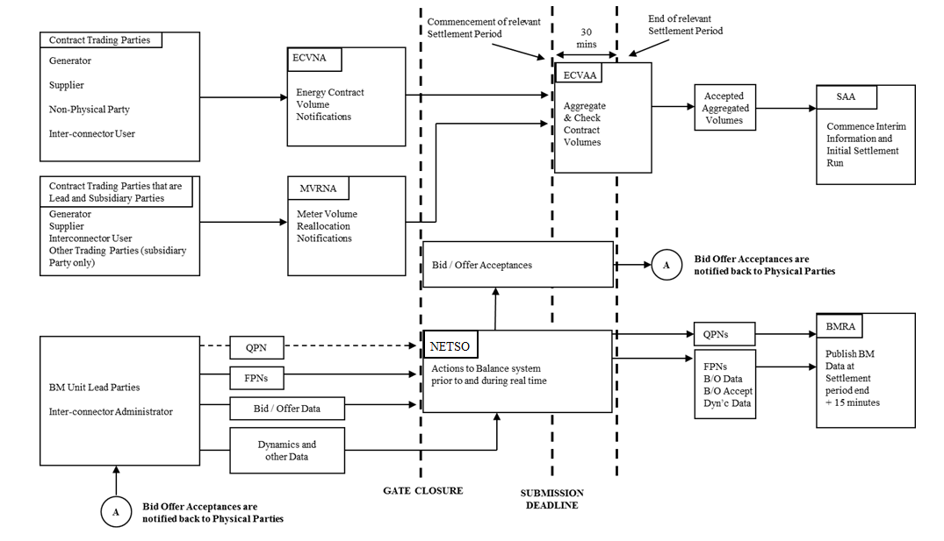

Please note that within this diagram, TC is the equivalent of NETSO

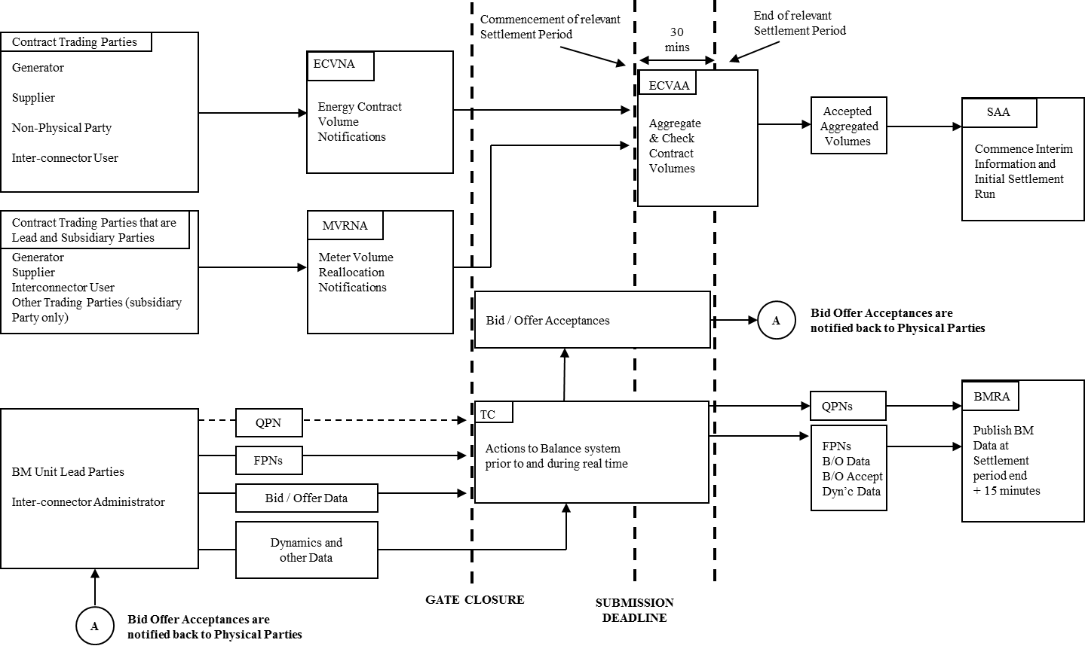

**3.3 Interim Information and Initial Volume Allocation / Settlement Runs**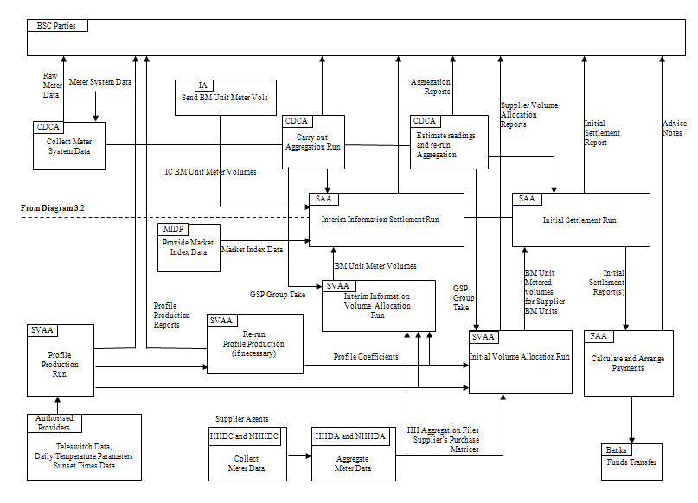

Supplier Volume Allocation Reports

**3.4 Reconciliation and Final Reconciliation Volume Allocation / Settlement Runs[1]**

Picture3

**3.5 Replacement Reserve Process**

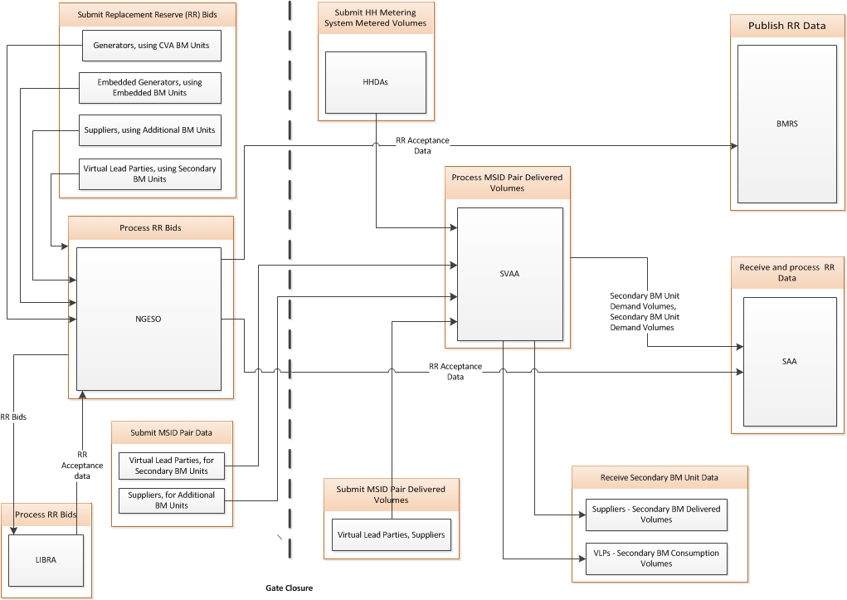

**4 Interface and Timetable Information**

**4.1 Interim Information and Initial Settlement Timetable and Settlement Reports**

This section covers the tasks required for the Interim Information and Initial Settlement Runs. The Interim Information run is carried out at approximately 5 WD, with no associated Payment Date. The Initial Settlement Run is carried out at approximately 16 WD, with an associated Payment Date of approximately 20 – 21 WD.

| **Ref** | **Task** | **Responsibility** | **Time-scale** |
| --- | --- | --- | --- |
| 1 | Send to ECVAA  Energy Contract Volume Notifications | ECVNA | To be received by ECVAA before the Submission Deadline |
| 2 | Send to ECVAA:  Meter Volume Reallocation Notifications | MVRNA | To be received by ECVAA before the Submission Deadline |
| 3 | Send the following information (for each BM Unit in respect of which the Lead Party is obliged to submit a FPN or has chosen to submit a FPN) to the NETSO:  Final Physical Notification Data  Bid / Offer Data (Required only if trading in Balancing Mechanism)  Dynamic Data | Lead Parties | To be received by the NETSO before Gate Closure |
| 4 | Send to BMRA:  Market Index Data | Market Index Data Providers | Target by end of Settlement Period |
| 5 | Accept Bids and Offers as required to meet forecast and actual system conditions. Acceptances which are taken to resolve transmission constraints are SO-Flagged. | NETSO | Not later than 15 minutes following the issue of an Acceptance; or  In the case of an Emergency Instruction, as soon as reasonably practicable. |
| 6 | Energy Transfer and Metering | Lead Parties | Settlement Period |
| 7 | Send the following information to BMRA (for information / storage) for each BM Unit in respect of which the Lead Party is obliged to submit a FPN or has chosen to submit a FPN to the NETSO:  Maximum Export Limit  Maximum Import Limit  Final Physical Notification Data  Dynamic Data  Bid Offer Data (for those BM Units for which such data has been provided)  Acceptance Data  System related Data  BM Unit Applicable Balancing Services Volume Data  Replacement Reserve Data | NETSO | Target Times:  Not later than 5 minutes following receipt  Not later than 15 minutes following Gate closure for each Settlement Period  Not later than 1200 hrs each day |
| 8 | Send Final Physical Notification Data to ECVAA.  Calculate Indicative System Buy Price and Indicative System Sell Price and publish relevant data | BMRA | Upon receipt from the NETSO.  15 + CADL minutes after end of Settlement Period. |
| 9 | Send the following information to SAA to enable Settlement:  Final Physical Notification Data  Balancing Services Adjustment Data  Bid Offer Data  Acceptance Data  Any Dynamic Data received by the NETSO during the Settlement Day  BM Unit Applicable Balancing Services Volume Data | BMRA | The next day following the Settlement Day for Balancing Services Adjustment Data, and by 15 minutes following the end of the Settlement Day for the other items.  Within 2 Business Days following the relevant Settlement Period for BM Unit Applicable Balancing Services Volume Data |
| 10 | Interrogate Metering Systems registered by Parties with the CRA and collect consumption data.  Send to relevant Parties:  Raw Meter Data together with any validation criteria | CDCA | Send out by Settlement Day +1 (1300hrs) |
| 11 | Send to SVAA:  Tele-switch data | Tele-switch Agent | By +1 WD (by 1000hrs) |
| 12 | Obtain the following data from relevant authorised providers:  Daily temperature parameters by GSP Group  Sunset times by GSP Group (annually)  Perform Profile Production Run  Send Profile Reports to Suppliers and NHHDCs | SVAA | By +1 WD (by 1000hrs)  By +1 WD (by 1700hrs) |
| 13 | Send to SAA:  BM Unit Metered Volumes for the BM Units of each Interconnector User for each Interconnector | IA | By +1 WD |
| 14 | Send to SAA:  Market Index Data | Market Index Data Providers | By +1 WD |
| 15 | Send to SVAA  MSID Pair Delivered Volumes for procured balancing services | VLP | By +1 WD (by 1700hrs) |
| 16 | Suppliers raise query on Daily Profile Production Reports if necessary and log with Dispute Administrator | Supplier | By +3 WD (by 1000hrs) |
| 17 | Resolve Daily Profile Production query | SVAA | By +4 WD (by 1300hrs) |
| 18 | Amend Profile variables ready to re-run Daily Profile Production, if necessary | SVAA | By +4 WD (by 1500hrs) |
| 19 | If re-run of Daily Profile Production required then carry this out and send revised Daily Profile Production Reports to relevant Suppliers | SVAA | By +4 WD (by 1730hrs) |
| 20 | Collate information for use in the Interim Information Run  Send to SAA:  Meter Volume Reallocation Notification, by BM Unit for each Settlement Period  Account Bilateral Contract Volumes for each Settlement Period by BSC Party | ECVAA | In accordance with SAA Settlement Calendar |
| 21 | Carry out CDCA Aggregation for Interim Information Volume Allocation Run using the latest available data, i.e. valid actual meter data and/or agreed estimated meter data (for all missing or invalid readings) and the latest available approved Line Loss Factors, Aggregation Rules, Registration Data and Meter Technical Details.  Send to SAA:  BM Unit Metered Volumes for each BM Unit  GSP Group Take  Interconnector Metered Volumes  Send to SVAA:  GSP Group Take  Send to BSC Parties:  GSP Group Take  Send to Lead Party and NETSO  BM Unit Aggregation Report | CDCA | By + 4 WD (0900hrs) |
| 22 | Ensure Agents send to SVAA:  Half Hourly Aggregation Files from HHDAs  Half Hourly Metering System Metered Volumes from HHDAs  Supplier Purchase Matrices from NHHDAs | Suppliers | By +4 WD (0900hrs) |
| 23 | Carry out Interim Information Volume Allocation Run  Calculate the Supplier Volume Allocations for each BM Unit | SVAA | By +4 WD (from 0900hrs) |
| 24 | Send to SAA:  BM Unit Metered volumes for Supplier BM Units  Secondary BM Units Demand Volumes  Secondary BM Unit Delivered Volumes | SVAA | For receipt by + 5 WD (0900hrs) |
| 25 | Send Interim Information Volume Allocation Run Reports to relevant Suppliers | SVAA | By +5 WD |
| 36 | Carry out Interim Information Settlement Run using data from CDCA, ECVAA, SVAA, NETSO and MIDPs and send relevant reports to Parties.  Issue IIR Credits/Debits Report to ECVAA. | SAA | By + 5 WD or later if delayed in accordance with the Code |
| 27 | Implement SVAA resolution on profile query or request arbitration from Disputes Administrator | Supplier | By + 5 WD (by 1600hrs) |
| 28 | Communicate outcome of arbitration to affected Suppliers and SVAA | Dispute Administrator | By +7 WD (by 1000hrs) |
| 29 | If arbitration against SVAA, amend profile variables ready to re-run Daily Profile Production | SVAA | By +7 WD (by 1430hrs) |
| 30 | Implement results from arbitration and send revised profiles to affected Suppliers | SVAA | By +7 WD (by 1800hrs) |
| 31 | Send MSID Pair Delivered Volumes to SVAA | NETSO | By +11 WD[2] |
| 32 | Estimate volumes for missing or disputed data in accordance with the Code.  Carry out CDCA Aggregation for Initial Volume Allocation Run using the latest available data i.e. valid actual meter readings and/or any agreed estimates and the latest available approved Line Loss Factors, Aggregation Rules, Registration Data and Meter Technical Details.  Send to Parties:  GSP Group Take  Send to Lead Party and NETSO  BM Unit Aggregation Report  Send to SVAA:  GSP Group Take  Send to SAA:  CDCA Aggregation File | CDCA | For receipt by +14 WD |
| 33 | Ensure Agents send to SVAA:  Half Hourly Aggregation Files from HHDAs  Half Hourly Metering System Metered Volumes from HHDAs  Supplier Purchase Matrices from NHHDAs | Suppliers | By +14 WD |
| 34 | Carry out Initial Volume Allocation Run  Calculate the Supplier Volume Allocations for each BM Unit | SVAA | By +15 WD (from 0900hrs) |
| 35 | Send to SAA:  BM Unit Metered volumes for Supplier BM Units  Secondary BM Units Demand Volumes  Secondary BM Unit Delivered Volumes  Supplier BM Unit Non BMU ABSVD Volume[3] | SVAA | For receipt by + 16 WD (0900hrs) |
| 36 | Send:  Relevant Reports to NETSO  DUoS Report to Distribution Businesses  Initial Volume Allocation Run Reports to Suppliers | SVAA | By + 16 WD (before 1230hrs)  )  )By + 17 WD  ) |
| 37 | Carry out Initial Settlement Run using latest files from NETSO, ECVAA, CDCA and SVAA and MIDPs; and send relevant reports to BSC Parties.  Send Settlement Report to FAA | SAA | By +16 WD  (subject to SAA Settlement Calendar) or later if delayed in accordance with the Code  For receipt by + 17 WD (0900hrs)  (subject to Payment Calendar) |
| 38 | Receive Settlement Report from SAA  Calculate Payments | FAA | By +17–18 WD  (subject to Payment Calendar) |
| 39 | Send Advice Notes to Payment Parties | FAA | By +17–18 WD  (subject to Payment Calendar) |
| 40 | Funds transfers between Parties’ Banks | FAA | By +20–21 WD  (subject to Payment Calendar) |

**4.2 Reconciliation Timetable and Settlement Reports**

This section covers all Timetabled Volume Allocation Runs and all Timetabled Reconciliation Settlement Runs. The tasks required for the Interim Information and Initial Settlement Runs are defined in Section 4.1.

The following tasks are repeated at:

T = approximately 39 WD (between 36 and 40 WD) for the 1st Reconciliation Settlement Run;

T = approximately 84 WD (between 81 and 85 WD) for the 2nd Reconciliation Settlement Run;

T = approximately 154 WD (between 151 and 155 WD) for the 3rd Reconciliation Settlement Run; and

T = approximately 292 WD (between 289 and 293 WD) for the Final Reconciliation Settlement Run.

T is the Payment Date, expressed by reference to the Settlement Day.

In each case, the first figure reflects the target to be used in preparing the Payment Calendar, and all dates must be within the range specified in brackets. Precise timings for Reconciliation Settlement Runs and are governed by the Payment Calendar and/or SAA Settlement Calendar for the relevant period.

It should be noted that all tasks relating to all Timetabled Volume Allocation Runs and all Timetabled Reconciliation Settlement Runs may also be repeated in support of a Post Final Settlement Run up to and including 28 months after the Settlement Day[4].

| **Ref** | **Task** | **Responsibility** | **Time-scale (*)** |
| --- | --- | --- | --- |
| 1 | Ensure Agents send to SVAA:  Revised Half Hourly Aggregation Files from HHDAs  Half Hourly Metering System Metered Volumes from HHDAs  Revised Supplier Purchase Matrices from NHHDAs | Suppliers | By T – 6 WD  Note: Dependent on SVAA Calendar |
| 2 | Estimate volumes for missing or disputed data in accordance with the Code.  Re-run Aggregation Process using the latest available data i.e. valid actual meter data and/or any agreed estimates and the latest approved Line Loss Factors, Aggregation Rules, Registration Data and Meter Technical Details applicable for the relevant Settlement Day.  Send to Parties:  CDCA Aggregation Reports  Send to SVAA:  GSP Group Take  Send to SAA:  CDCA Aggregation File | CDCA | By T – 6 WD  Note: Dependent on SAA Settlement Calendar |
| 3 | Carry out Reconciliation Volume Allocation Run  Calculate the Supplier Volume Allocation for each BM Unit. | SVAA | By T – 5 WD  Note: Dependent on SVAA Calendar |
| 4 | Send to SAA  BM Unit Metered Volumes for Supplier BM Units  Secondary BM Units Demand Volumes  Secondary BM Unit Delivered Volumes  Supplier BM Unit Non BMU ABSVD Volume | SVAA | For receipt by T – 4 WD (0900hrs)  Note: Dependent on SVAA Calendar |
| 5 | Send:  Relevant Reports to NETSO  Updated DUoS Report to Distribution Businesses  Reconciliation Volume Allocation Run Reports to Suppliers | SVAA | By T – 4 WD (before 1230hrs)  )  ) By T – 3 WD  ) |
| 6 * | Carry out Reconciliation Settlement Run using latest available files from NETSO, ECVAA, CDCA and SVAA and MIDP  Send to FAA  Reconciliation Settlement Report  Send to BSC Parties:  Reports on financial position | SAA | By T – 4 WD  For receipt by T – 3 (0900hrs) |
| 7 | Receive Reconciliation Settlement Report from SAA (Notification Date)  Calculate Payments | FAA | By T – 3 WD |
| 8 | Send to Parties  Advice Notes | FAA | By T – 3 WD |
| 9 | Authorise the financial transfers between Parties’ Banks (Payment Date) | FAA | By T |
| 10 | Send MSID Pair Delivered Volumes to SVAA | NETSO | No later than SD + 45 calendar days[5] |

(*) Precise timings are governed by the Payment Calendar and/or SAA Settlement Calendar and/or SVAA Calendar.

**4.3 Produce Payment Calendar and SAA Settlement Calendar (transferred to BSCP301)**

Note: this has been amended to include both FAA and SAA obligations and has been transferred to BSCP301 (Clearing, Invoicing and Payment).

**5 Appendices**

**5.1 Interim Information Settlement Run**

If the SAA detects invalid or missing data in respect of the relevant Settlement Day prior to carrying out the relevant Settlement Run for the following data items:

Final Physical Notification Data (from BMRA/NETSO)

Balancing Services Adjustment Data (from BMRA/NETSO)

Bid Offer Data (from BMRA/NETSO)

Acceptance Data (from BMRA/NETSO)

BM Unit Applicable Balancing Services Volume Data (from BMRA/NETSO)

BM Unit Metered Volumes for Interconnector BM Units (from IA)

BM Unit Metered Volumes for BM Units other than Supplier BM Units and Interconnector BM Units (from CDCA)

Metered Volume Reallocations by BM Unit (from ECVAA)

Account Bilateral Contract Volumes (from ECVAA)

GSP Group Take for each GSP Group (from CDCA)

Interconnector Metered Volumes (from CDCA); and

Market Index Data (from MIDP)

BM Unit Metered Volumes for Supplier BM Units (from SVAA)

Secondary BM Units Demand Volumes and Secondary BM Unit Delivered Volumes (from SVAA)

Then the SAA shall inform BSCCo and proceed in accordance with BSCCo instruction.

In the event that the SAA receives invalid or missing data and is required to consult with BSCCo, the decision on whether and what default data should be substituted shall be at the absolute discretion of BSCCo.

When incomplete data is submitted for an Interim Information Settlement Run, section T1.4.2 of the BSC states that the SAA should form an opinion on whether the proportion of data missing is 'significant', and whether the missing data is likely to be received by the end of the next Business Day, before seeking instructions from BSCCo. In practice, however, both BSCCo and the SAA prefer that BSCCo should take the lead in reaching decisions on these issues. For this reason, the SAA informs BSCCo of missing or invalid data in all cases.

**5.2 Initial Settlement Run**

If the SAA does not expect to receive substantially complete and valid data in respect of the relevant Settlement Day in time to carry out the relevant Settlement Run for the following data items:

Final Physical Notification Data

Balancing Services Adjustment Data

Bid Offer Data

Acceptance Data

BM Unit Applicable Balancing Services Volume Data

BM Unit Metered Volumes for Interconnector BM Units (from IA)

BM Unit Metered Volumes for Supplier BM Units (from SVAA)

Secondary BM Units Demand Volumes and Secondary BM Unit Delivered Volumes (from SVAA)

BM Unit Metered Volumes for BM Units other than Supplier BM Units and Interconnector BM Units (from CDCA)

Metered Volume Reallocations;

Account Bilateral Contract Volumes;

GSP Group Take for each GSP Group;

Interconnector Metered Volumes; and

Market Index Data

The SAA shall consult BSCCo and proceed in accordance with the BSC under BSCCo instruction. The decision by BSCCo on whether and what default data should be substituted shall be at the absolute discretion of BSCCo.

When incomplete data is submitted for an Initial Settlement Run, Section T1.4.5 of the BSC states that the SAA should form an opinion on whether the data is 'substantially complete' before seeking instructions from BSCCo. In practice, however, both BSCCo and the SAA prefer that BSCCo should take the lead in reaching decisions on these issues. For this reason, the SAA will inform BSCCo of missing or invalid data in all cases.

1. Where an upheld Trading Dispute is to be processed after the Final Reconciliation Settlement Run has been performed then a Post-Final Settlement Run or Extra-Settlement Determination may be required as described in BSCP11.
2. Where such data is available to the NETSO
3. Relating to the MSID Pair Delivered Volumes received by the SVAA
4. Note that that Post-Final Settlement or Volume Allocation Runs may be requested after 28 months, but only for the purposes of the Rectification of Past Notification Error
5. Where such data has not been supplied already under Section 4.1, 33.