Balancing and Settlement Code

Code of Practice Eleven

CODE OF PRACTICE FOR ASSET METERING FOR USE IN BALANCING SERVICES REGISTRATION VALIDATION

Issue 0.4

Version 0.1

Date: 6 August 2019

Code of Practice Eleven
CODE OF PRACTICE FOR ASSET METERING FOR USE IN BALANCING SERVICES REGISTRATION VALIDATION

- Reference is made to the Balancing and Settlement Code for the Electricity Industry in Great Britain, and in particular, to the definition of “Code of Practice” in Annex X-1 thereof.
- This is Code of Practice Eleven, Issue ##, Version ##.
- This Code of Practice shall apply to Metering Systems comprising Metering Equipment that are subject to the requirements of Section L of the Balancing and Settlement Code.
- This Code of Practice is effective from ## xxxxxx ####.
- This Code of Practice has been approved by the Panel.

Intellectual Property Rights, Copyright and Disclaimer
The copyright and other intellectual property rights in this document are vested in ELEXON or appear with the consent of the copyright owner. These materials are made available for you for the purposes of your participation in the electricity industry. If you have an interest in the electricity industry, you may view, download, copy, distribute, modify, transmit, publish, sell or create derivative works (in whatever format) from this document or in other cases use for personal academic or other non-commercial purposes. All copyright and other proprietary notices contained in the document must be retained on any copy you make.
All other rights of the copyright owner not expressly dealt with above are reserved.
No representation, warranty or guarantee is made that the information in this document is accurate or complete. While care is taken in the collection and provision of this information, ELEXON Limited shall not be liable for any errors, omissions, misstatements or mistakes in any information or damages resulting from the use of this information or action taken in reliance on it.

AMENDMENT RECORD

Issue | Date | Version | Description of Changes | Changes Included | Mods/ Panel/ Committee Refs
0.1 | 8/5/2019 |  | Initial draft for P375 WG review |  | P375
0.2 | 28/5/2019 |  | Updated following P375 WG comments |  | P375
0.3 | 09/07/2019 |  | Updated following P375 WG comments |  | P375
0.4 | 06/08/2019 |  | Updated following internal comments |  | P375

CONTENTS
Page Number
Foreword 5
1. Scope 5
2. References 6
3. Definitions and Interpretations 7
4. Measurement Criteria 12
5. Accuracy Requirements 14
6. Metering Equipment Criteria 16
7. Testing Facilities 26
8. Sealing 26
9. Commissioning and Proving 26
10. Single Line Diagram 27
11. Difference Metering 27
12. Record Keeping 28
Appendix A – Defined Metering at the Asset Point 30
Appendix B – Import/Export Convention 33
Appendix C – Half Hourly Integral Outstation / Separate Outstation Requirements 34
1. Outstation 34
2. Displays 35
3. Data storage 36
4. Time Keeping 36
5. Monitoring Facilities 36
6. Communications 37
7. Local Interrogation 38
8. Remote Interrogation 39
Appendix D – Commissioning Requirements 40
Appendix E – Single Line Diagram Requirements 44
Appendix F – Asset Metering Complex Site Supplementary Information Form (CoP11/Fa) 45

FOREWORD
This Code of Practice defines the minimum requirements for the Metering Equipment required for the measurement and recording of electricity at an asset which is located behind a Boundary Point Metering System. This is either based on the rated capacity of the circuit or the Maximum Demand, as applicable.

For the avoidance of doubt this Code of Practice is not for Boundary Point Metering Systems. For those Metering Systems refer to the relevant Code of Practice 1, 2, 3, 4, 5 and 10 as applicable.

For the purpose of this Code of Practice the rated circuit capacity in MVA shall be determined by the lowest rated primary plant (e.g. transformer rating, line rating, etc) of the circuit. The Metering Equipment provision and accuracy requirements shall anticipate any future uprating consistent with the installed primary plant. The primary plant maximum continuous ratings shall be used in this assessment.

For the purpose of this Code of Practice the Maximum Demand of the electricity being transferred does not exceed 1MW or 100kW depending on whether Asset Metering Type 4 or 5.

For the purpose of this Code of Practice, the use of summation current transformers shall not be permitted. The use of interposing current transformers is permitted providing the overall
Asset Metering System accuracy is maintained.

Where a material change to an Asset Metering System takes place, then this Metering System must be modified to comply with the most up to date version of this Code of Practice. Changes to an Asset Metering System are considered to be material where they constitute a change to:

- Switchgear containing Measurement Transformers; and/or
- The primary plant associated with the Asset Metering System i.e. Measurement Transformers.

BSCCo shall retain copies of, inter alia, this Code of Practice together with copies of all documents referred to in it, in accordance with the provisions of the Balancing and Settlement Code (“the Code”).

SCOPE
This Code of Practice states the practices that shall be employed, and the facilities that shall be provided for the measurement and recording of the quantities required for Metering at the Asset which is behind the Boundary Point Metering System.

This Code of Practice specifically applies to the Metering Equipment to be installed at each asset that is required to be metered to determine the Metered Volumes of that asset. This can be at multiple locations (i.e. on multiple circuits) behind the Boundary Point Metering System.

This Code of Practice applies equally to "whole current" metering and metering supplied via Measurement Transformers operating at high or low voltages.

In the event of an inconsistency between the provisions of this Code of Practice and the Code, the provisions of the Code shall prevail.

REFERENCES
The following documents are referred to in the text:-
BS EN/IEC 62053-21 Electricity metering equipment (a.c.). Particular requirements. Static meters for active energy (classes 1 and 2)
BS EN/IEC 62053-22 Electricity metering equipment (a.c.). Particular requirements. Static meters for active energy (classes 0,2 S and 0,5 S)
BS EN/IEC 62053-23 Electricity metering equipment (a.c.). Particular requirements. Static meters for reactive energy (classes 2 and 3)
BS EN 50470-3 Electricity metering equipment (a.c.). Particular requirements. Static meters for active energy (class indexes A, B and C)
BS EN/IEC 61557-12 Electrical safety in low voltage distribution systems up to 1000 V a.c. and 1500 V d.c. Equipment for testing, measuring or monitoring of protective measures. Performance measuring and monitoring devices (PMD)
BS EN/IEC 60688-2.2 Electrical measuring transducers for converting a.c. electrical quantities to analogue or digital signals
BS EN/IEC 61869-2 Instrument transformers. Additional requirements for current transformers
BS EN/IEC 61869-3 Instrument transformers. Additional requirements for inductive voltage transformers
BS EN/IEC 61869-4 Instrument Transformers – Combined Transformers
BS EN/IEC 62056-21 Electricity metering. Data exchange for meter reading, tariff and load control. Direct local data exchange

DEFINITIONS AND INTERPRETATIONS
  - Active Energy
Active Energy means the electrical energy produced, flowing or supplied by an electrical circuit during a time interval, and being the integral with respect to time of the instantaneous Active Power, measured in units of watt-hours or standard multiples thereof.
  - Active Power
Active Power means the product of voltage and the in-phase component of alternating current measured in units of watts and standard multiples thereof, that is:-
1,000 Watts = 1 kW
1,000 kW = 1 MW

  - Actual Metering Point
Actual Metering Point means the physical location at which electricity is metered.

  - Apparent Energy
Apparent Energy means the integral with respect to time of the Apparent Power.

  - Asset Export
Asset Export means, for the purposes of this Code of Practice, an electricity flow as indicated in Figure 5 of Appendix B.
  - Asset Import
Asset Import means, for the purposes of this Code of Practice, an electricity flow as indicated in Figure 5 of Appendix B.
  - Apparent Power
Apparent Power means the product of voltage and current measured in units of volt-amperes and standard multiples thereof, that is:-
1,000 VA = 1 kVA
1,000 kVA = 1 MVA

  - Asset Meter
Asset Meter means a device for measuring Active Energy and/or Active Power and/or Reactive Energy and/or Reactive Power. It includes both Half Hourly Integral Outstation Meters and Meters that do not measure on a half hourly basis.

  - Asset Metering Type
Asset Metering Type means the category of Metering Equipment required to be compliant with this Code of Practice. The categories are split by the rated capacity of the circuit being measured or by the maximum demand of the energy transfers of the circuit being measured. There are five categories:
- Asset Metering Type 1 (Metering of circuits rated greater than 100MVA);
- Asset Metering Type 2 (Metering of circuits not exceeding 100MVA);
- Asset Metering Type 3 (Metering of circuits not exceeding 10MVA);
- Asset Metering Type 4 (Metering of energy transfers with a maximum demand of up to (and including) 1MW); and
- Asset Metering Type 5 (Metering embedded within another device for energy transfers with a maximum demand of up to (and including) 100kW).

  - Auxiliary Load
Auxiliary Load means the total amount of electricity used by a generating unit for purposes directly related to its operation, whether or not that electricity is generated by the unit or used while the unit is generating electricity.

  - Boundary Point Metering System
The Boundary Point Metering System means a Metering System which measures exports or imports at a point at which any Plant or Apparatus not forming part of the Total System is connected to the Total System. Where the Total System means the Transmission System, each Offshore Transmission System User Asset and each Distribution System.

  - Data Retriever Instation
Data Retriever Instation means a computer based system which collects or receives data on a routine basis from selected Asset Meters by the relevant Data Retriever. This system may also be used to collect data for other purposes such as for a relevant balancing service for the National Grid Electricity System Operator or the Capacity Market.

  - Defined Metering at the Asset Point
Defined Metering at the Asset Point means the physical location at which the Overall Accuracy requirement as stated in this Code of Practice are to be met. The Defined Metering at the Asset Point is identified in Appendix A and relates to metering at the asset for Dependent Load of that asset. For a generating unit this must be in such a position(s) to determine Net Output.

  - Demand Period
Demand Period means the period over which Active Energy, Reactive Energy or Apparent Energy are integrated to produce Demand Values. For Settlement purposes, currently each Demand Period shall be of 30 minutes duration, one of which shall finish at 24:00 hours. The Asset Metering System must be capable of other durations, these being 20, 15, 10 and 5 minutes with one demand period ending on the hour, should the requirements of Settlement change.

  - Demand Values
Demand Values, expressed in MW, Mvar or MVA, means twice the value of MWh, Mvarh or MVAh recorded during any Demand Period (Please note that these Demand Values are for use with Metering Systems using Asset Metering Types 1 and 2. Metering Systems using Asset Metering Types 3 and 4 shall use units a factor of 10³ smaller e.g. kW rather than MW). The Demand Values are half hour demands and these are identified by the time of the end of the Demand Period.
Where Settlement requires a Demand Period that is not of thirty minute duration the relationship between Watts (W) and Watt-hours (Wh) will be:
$$Watts \left(W\right)=\left(\frac{60 minutes}{Demand Period Duration \left(minutes\right)}\right)×Wh$$
For example, a 15 minute Demand Period duration would mean that Demand Values expressed in MW are four times the value of MWh recorded during the Demand Period.

  - Dependent Load
A Dependent Load is any source of generation or demand that is directly associated with the Dispatchable Asset. This includes the output of the asset itself and any circuit that will change its mode of operation or level of output in direct response to the Dispatchable Asset being activated. For a generating unit Dependent Load must include all Auxiliary Load for that generating unit and the generated output.

  - Difference Metering
Difference Metering is an arrangement where the Metered Volumes of the Asset Dependent Load are determined by subtracting Asset Metering Metered Volumes for all load not constituting the relevant Asset Dependent Load from the Boundary Point Metering System metered volumes.
This can be Asset Metering measuring all of the Independent Load, or all the Dependant Load for a Dispatchable Asset for another Party, behind the Boundary Point Metering System that the Dispatchable Asset is located.

  - Dispatchable Asset
An asset that is controllable and can be used on demand. These assets can be a source of generation or a demand that can be switched on or off as required.

  - Electricity
"electricity" means Active Energy and Reactive Energy.

  - Half Hourly Integral Outstation Meter
Half Hourly Integral Outstation Meter means an Asset Meter that is capable of measuring Active Energy and/or Reactive Energy in Demand Period format; and is capable of two way remote communication.

  - Independent Load
An Independant Load is any source of generation or demand that is not directly associated with the Dispatchable Asset but is located behind the same Boundary Point Metering System. This includes any circuit that will not change its mode of operation or level of output in direct response to the Dispatchable Asset being activated.

  - Instation
Instation means either a Settlement Instation or a Data Retriever Instation.

  - Measurement Transformers
Measurement Transformers means either a Current Transformer (CT) or a Voltage Transformer (VT) or a device carrying out both such functions, whose purpose is to enable the Metering Equipment to operate at more convenient currents and/or voltages (as applicable) than are present on the power system being measured

  - Metering Equipment
Metering Equipment means Meters, Measurement Transformers (voltage, current and combination units), metering protection equipment including alarms, circuitry, associated Communications Equipment and Outstation and wiring.

  - Meter Register
Meter Register means a device, normally associated with a Meter, from which it is possible to obtain a reading of the amount of Active Energy, or the amount of Reactive Energy that has been supplied by a circuit.
  - Net Output
Net Output means the amount of electricity produced by a generating unit minus its Auxiliary Load.

  - Outstation
Outstation means equipment which receives and stores data from an Asset Meter(s) for the purpose, inter-alia, of transfer of that metering data to the relevant Data Collector as the case may be and which may perform some processing before such transfer and may be in one or more separate units or may be integral with the Asset Meter (i.e. a Half Hourly Integral Outstation Meter).

  - Overall Accuracy
Overall Accuracy means the difference between the measured energy and the true energy at the Defined Metering at the Asset Point after taking account of all Compensations deliberately set into the Asset Meter and is expressed as a percentage of the true energy. The Overall Accuracy criterion for an Asset Metering System is as stated for the relevant Asset Metering Type in this Code of Practice.

  - Password
For Half Hourly Integral Outstation Meters approved under BSCP601 for use in Code of Practice 1, 2, 3 and 5 (see 6.1): ‘Password’ means a string of characters of length no less than six characters and no more than twelve characters, where each character is a case insensitive or sensitive alpha character (A to Z) or a digit (0 to 9) or the underscore character (_).
For a Meter approved under BSCP601 for Code of Practice 10 a security regime shall be provided to prevent unauthorised access to the data in the Metering Equipment. A three level security regime shall be provided as per levels 1, 2 and 3 in Appendix C section 6.
For separate Outstations (see 6.1): a Password may be described as above for Half Hourly Integral Outstations or a single password of any format (Asset Meters separate from their Outstation and capable of external communications should have the same password requirements as for separate Outstations).

  - Rated Measuring Current
Rated Measuring Current means the rated primary current of the current transformers in primary plant used for the purposes of measurement.

  - Reactive Energy
Reactive Energy means the integral with respect to time of the Reactive Power and for the purpose of the Code, is comprised of Active Export Related Reactive Energy and Active Import Related Reactive Energy.

  - Reactive Power
Reactive Power means the product of voltage and current and the sine of the phase angle between them, measured in units of volt-amperes reactive and standard multiples thereof.

  - Settlement Instation
Settlement Instation means a computer based system which collects or receives data on a routine basis from a selected Outstation by the relevant Data Collector.
  - Single Line Diagram
A simplified notation for representing a three-phase power system that must show Independent and Dependent Load circuits behind a Boundary Point Metering System. The Single Line Diagram must also show that Boundary point Metering System.

MEASUREMENT CRITERIA
Asset Meters can be designed to measure energy and/or power; the functionality of the Asset Meter may be that it only records or transmits Metered Volume data to an Instation in one of these formats (i.e. energy or power). Dependant on the functionality of the Asset Meter one or both of the Measured Quantities and Demand Values may be applicable.

    - Measured Quantities
For each separate circuit the following Active Energy measurements are required for metering at the asset:-
- Import kWh/MWh*
- Export kWh/MWh*
* Import and/or Export metering need only be installed where the circuit being metered is capable of import and/or export flows of energy.
Where the installed metering is capable of the measurement of Reactive Energy then for each separate circuit the following energy measurements are required for metering at the asset:-
- Import kvarh/Mvarh
- Export kvarh/Mvarh

Or if the meter is capable of four quadrant reactive measurement and Reactive Energy is required to be metered in that format:
- Active Import related Import kvarh/Mvarh
- Active Import related Export kvarh/Mvarh
- Active Export related Import kvarh/Mvarh
- Active Export related Export kvarh/Mvarh

    - Demand Values
For each separate circuit the following Active Power Demand Values are required for metering at the asset:-
- Import kW/MW*
- Export kW/MW*
* Import and/or Export metering need only be installed where the circuit being metered is capable of import and/or export flows of energy.
Where the installed metering is capable of the measurement of Reactive power then for each separate circuit the following Demand Values are required for metering at the asset:-
- Import kvar/Mvar
- Export kvar/Mvar

Or if the meter is capable of four quadrant reactive measurement and Reactive Power is required to be metered in that format:
- Active Import related Import kvar/Mvar
- Active Import related Export kvar/Mvar
- Active Export related Import kvar/Mvar
- Active Export related Export kvar/Mvar

ACCURACY REQUIREMENTS

The Overall Accuracy of the energy measurements at or referred to a Defined Metering at the Asset Point for metering at the asset shall at all times be within the limits of error for the applicable Asset Metering Type as shown below:

Table 1: Asset Metering Type 1 (Metering of circuits rated greater than 100MVA)
CONDITION | LIMITS OF ERROR AT STATED SYSTEM POWER FACTOR
Current expressed as a percentage of Rated Measuring Current | Power Factor | Limits of Error
120% to 10% inclusive  Below 10% to 5%  Below 5% to 1%  120% to 10% inclusive | 1  1  1  0.5 lag and 0.8 lead | ± 0.5%  ± 0.7%  ± 1.5%  ± 1.0%

Table 2: Asset Metering Type 2 (Metering of circuits not exceeding 100MVA)
CONDITION | LIMITS OF ERROR AT STATED SYSTEM POWER FACTOR
Current expressed as a percentage of Rated Measuring Current | Power Factor | Limits of Error
120% to 10% inclusive  Below 10% to 5%  Below 5% to 1%  120% to 10% inclusive | 1  1  1  0.5 lag and 0.8 lead | ± 1.0%  ± 1.5%  ± 2.5%  ± 2.0%

Table 3: Asset Metering Type 3 (Metering of circuits not exceeding 10MVA)
CONDITION | LIMITS OF ERROR AT STATED SYSTEM POWER FACTOR
Current expressed as a percentage of Rated Measuring Current | Power Factor | Limits of Error
120% to 10% inclusive  Below 10% to 5%  120% to 10% inclusive | 1  1  0.5 lag and 0.8 lead | ± 1.5%  ± 2.0%  ± 2.5%

Table 4: Asset Metering Type 4 (Metering of energy transfers with a maximum demand of up to (and including) 1MW)
CONDITION | LIMITS OF ERROR AT STATED SYSTEM POWER FACTOR
Current expressed as a percentage of Rated Measuring Current | Power Factor | Limits of Error
100% to 20% inclusive  Below 20% to 5%  100% to 20% inclusive | 1  1  0.5 lag and 0.8 lead | ± 1.5%  ± 2.5%  ± 2.5%

Table 5: Asset Metering Type 5 (Metering embedded within another device for energy transfers with a maximum demand of up to (and including) 100kW)
CONDITION | LIMITS OF ERROR AT STATED SYSTEM POWER FACTOR
Current expressed as the operational range of the device | Power Factor | Limits of Error
I_{n} to I_{max} inclusive | All | - 3.5% to + 2.5%

Where I_{n} is the nominal current the device is designed to operate at and I_{max} is the maximum current the device is designed to operate at. For example, if a device was designed to only operate in the 6A-32A range I_{n} would be 6A and I_{max} 32A.
The Overall Accuracy must include the errors for all Metering Equipment making up the Asset Metering System. For a high voltage Metering System this will include the Voltage Transformers, Current Transformers and the Asset Meter; for low voltage high current this will include the Current Transformers and the Asset Meter; and for low voltage low current (i.e. whole current) this will only include the Asset Meter.

  - Compensation for Measurement Transformer Error
To achieve the Overall Accuracy requirements it may be necessary to compensate Asset Meters for the error of the Measurement Transformers and the associated leads to the Asset Meters. Values of the compensation shall be recorded and evidence to justify the compensation criteria, including wherever possible test certificates, shall be available for inspection by the Panel or Technical Assurance Agent.

METERING EQUIPMENT CRITERIA
Users of this Code of Practice shall ensure that all Metering Equipment are:
- installed and commissioned (if not already installed and commissioned); and
- maintained and operated.

6.1 Asset Meters

Asset Meters can be split into three categories as described below:

- Meters approved for use in Code of Practice 1, 2, 3, 5 and 10 that are a Half Hourly Integral Outstation. See Section 6.1.1;

- Meters that are dedicated to the purpose of Active Power and/or Active Energy measurement that are not Half Hourly Integral Outstation See Section 6.1.2; and

- Meters that are not dedicated to the purpose of Active Power and/or Active Energy measurement and are not Half Hourly Integral Outstation. These metering devices are embedded within equipment used for other purposes, such as an EV charging unit or a small scale domestic battery storage unit. See Section 6.1.3.

For each circuit Asset Meters do not need to be replaced as long as the meter continues to meet the stipulated accuracy requirements, however the meter must be re-calibrated every 10 years from the date of manufacture for Asset Metering Types 1 and 2; and every 15 years from the date of manufacture for Asset Metering Types 3, 4 and 5.

All Asset Metering Systems should include an ability to record or convert data into a half hourly energy format, this can either be done by:

- Outstation functionality that can be either integrated or separate to the Asset Meter; Or
- Data Retriever Instation.

All Asset Meters should have a calibration test certificate indicating conformity with the accuracy requirements appropriate to the Asset Meter Type, accuracy class and relevant IEC standard (if applicable). The test equipment used to test the Asset Meter shall be traceable to an Accredited Laboratory; where an Accredited Laboratory is The National Physical Laboratory (NPL), or a Calibration laboratory that has been accredited by the United Kingdom Accreditation Service (UKAS), or a similarly accredited international body.

Asset Meters shall be configured such that the number of measuring elements is equal to or one less than the number of primary system conductors. These include the neutral conductor, and/or the earth conductor where system configurations enable the flow of zero sequence energy.

All Asset Meters supplied via Measurement Transformers shall be set to the actual primary and secondary ratings of the Measurement Transformers and the ratios displayed as follows:
- for Asset Meters separate from the display and/or Outstation the ratios shall be recorded on the nameplate of the Asset Meter; and
- for Asset Meters combined with the display the ratios shall be displayed.

    - Half Hourly Integral Outstation Meters (Code of Practice 1, 2, 3, 5 and 10 approved)

For Asset Metering Types 1, 2 and 3 circuits shall be measured by both main and check Asset Meters.

All Half Hourly Integral Outstation Meters and separate Outstations (located at the same location as the Half Hourly Integral Outstation Meters) shall be to a format and protocol approved by the Panel in accordance with BSCP601 ‘Metering Protocol Approval and Compliance Testing’; and be static and configured to measure on a half hourly basis. This approval will be for Code of Practices 1, 2, 3, 5 and 10 as applicable. So long as the minimum accuracy classes for this Code of Practice are met a Meter approved for use in Code of Practice 1, 2, 3, 5 and 10 can be used as an Asset Meter; Table 6 shows the equivalence between the Codes of Practices (1, 2, 3, 5 and 10) and the Asset Metering Type.

Table 6: Asset Metering Type Code of Practice Compliance

CODE OF PRACTICE COMPLIANCE | ASSET METERING TYPE
1 | 1
2 | 2
3 | 3
5 | 4
10 | 4
N/A | 5

Half Hourly Integral Outstation Meters (where approved through BSCP601 for Code of Practices 1, 2, 3, 5 and 10 as applicable) shall have the facilities, Outstation functionality and communications requirements set out in Appendix C.

All Half Hourly Integral Outstation Meters shall include a non-volatile Meter Register of cumulative energy for each measured quantity. The Meter Register(s) shall not roll-over more than once within a six month period.

The required minimum accuracy class that shall be installed will be to the accuracy class defined in Table 7, as applicable.

Table 7: All Half Hourly Integral Outstation Meters and Asset Meters that measure and record Energy for Asset Metering Type 1, 2, 3 and 4 metering should meet the following criteria:
Asset Metering Type | Relevant Standard | Minimum Class Accuracy
1 | BS EN 62053-22 |  | 0.2s
2 | BS EN 62053-22  BS EN 50470-3 |  | 0.5s  C
3 | BS EN 62053-21  BS EN 50470-3 |  | 1  B
4 | BS EN 62053-21  BS EN 50470-3 |  | 1  B

The standards quoted are the current standards for Asset Meters at those accuracy classes. Any Asset Meter currently installed pre-dating these standards should meet the applicable standard at the time of installation.

    - Meters that are dedicated to the purpose of Active Power and/or Active Energy measurement that are not Half Hourly Integral Outstation

All dedicated Asset Meters that are not Half Hourly Integral Outstation Meters shall be to a format compliant with IEC 61557-12, IEC 60688-2.2 and/or IEC 62053-2x, as applicable. They shall be to a format and protocol approved by the Panel in accordance with BSCP601 ‘Metering Protocol Approval and Compliance Testing’ for Code of Practice 11. For the avoidance of doubt a dedicated Asset Meter is a device whose sole purpose is for the measurement of Active Power and/or Active Energy and is not embedded within a device used for other purposes (e.g. an EV charging unit or a small scale domestic battery storage unit).

All dedicated Asset Meters that are not Half Hourly Integral Outstation Meters shall, where a display functionality is available, display cumulative energy registers, programmed Measurement Transformer ratios, instantaneous parameters (i.e. power), output values (e.g. pulse output based on power or energy) programmed to be sent to an Instation. Where these parameters cannot be shown on the Asset Meter display they shall have a facility to download them from the Asset Meter either locally or remotely.

All dedicated Asset Meters that are not Half Hourly Integral Outstation Meters shall, where a display functionality is not available, have a facility to download from the Asset Meter either locally or remotely cumulative energy registers, programmed Measurement Transformer ratios, instantaneous parameters (i.e. power), output values (e.g. pulse output based on power or energy) programmed to be sent to an Instation.

All Asset Meters that are not Half Hourly Integral Outstation Meters that have a non-volatile Meter Register that can be displayed on the Asset Meter shall be configured to display the cumulative energy for each measured quantity. The Asset Meter Register(s) shall not roll-over more than once within a six month period.

Where the Asset Meter has an internal clock and this clock is the basis for the configuration of data submitted into Settlement:

- The Asset Meter time shall be set to the Universal Time Clock (UTC) also known as Greenwich Mean Time (GMT). No switching between UTC and British Summer Time (BST) shall occur;
- Time synchronisation of the Asset Meter may be performed remotely by the Settlement Instation as part of the normal interrogation process or locally by an Interrogation Unit;
- The overall limits of error for the time keeping allowing for a failure to communicate with the Asset Meter for an extended period of 10 days for Asset Metering Type 1 and 2 or 20 days for Asset Metering Type 3 and 4 shall be:-
- the completion of each Demand Period shall be at a time which is within ±10 seconds of UTC for Asset Metering Type 1 and 2 or ±20 seconds of UTC for Asset Metering Type 3 and 4; and
- the duration of each Demand period shall be within ±0.1%, except where time synchronisation has occurred in a Demand Period.
The required minimum accuracy class that shall be installed will be to the accuracy class defined in Table 7 (see Section 6.1.1) or Table 8, as applicable.

Table 8: All Asset Meters that only measure and record instantaneous Active Power, this includes Asset Meters that are capable of measuring Energy but where an instantaneous Active Power output is used to provide data to an Instation, for Asset Metering Type 1, 2, 3 and 4 metering should meet the following criteria:
Asset Metering Type | Relevant Standard | Minimum Class Accuracy
1 | IEC 61557-12  IEC 60688-2.2 |  | 0.2
2 | IEC 61557-12  IEC 60688-2.2 |  | 0.5
3 | IEC 61557-12  IEC 60688-2.2 |  | 1
4 | IEC 61557-12  IEC 60688-2.2 |  | 1

The standard quoted is the current standards for Meters at those accuracy classes. Any Active Power Asset Meter currently installed pre-dating these standards should meet the applicable standard at the time of installation.

    - Meters that are not dedicated to the purpose of Active Power and/or Active Energy measurement and are not Half Hourly Integral Outstation. These metering devices are embedded within equipment used for other purposes

All Asset Meters that are not dedicated meters and are integrated into a device (for example an EV charging unit or a small scale domestic battery storage unit) must have an integrated metering device that meets the limits of error defined in Table 9; the limits of error requirement must include any Measurement Transformers within the equipment that are making up the metering device.

Table 9: All Asset Meters embedded within a device measuring a.c. should meet the following criteria:

CONDITION | LIMITS OF ERROR AT STATED SYSTEM POWER FACTOR
Current expressed as the operational range of the device | Power Factor | Limits of Error
I_{max} to 50% I_{max} inclusive  Below 50% I_{max} to I_{n}  I_{max} to I_{n} inclusive | 1  1  0.5 lag and 0.8 lead | ± 2.0%  ± 2.5%  ± 2.5%

Where the device is converting a.c. electrical quantities to d.c. electrical quantities the metering device shall be in such a place within the product to account for any losses associated with the inverter. Where it is not the losses of the inverter must be accounted for in the aggregation rule using the Asset Metering Complex Site Supplementary Information Form (CoP11/Fa) (see Appendix F). The losses in the inverter must be independently verified (in accordance with BSCP601 ‘Metering Protocol Approval and Compliance Testing’ for Code of Practice 11) and results made available for inspection by the Panel or Technical Assurance Agent.

The inverter loss tests should be for a specific make, model and type and where the inverter make, model and type is changed the inverter loss tests should be carried out again. Where the losses have changed the new figure must be used in the Asset Metering Complex Site Supplementary Information Form (CoP11/Fa) (see Appendix F) for the relevant configuration of device.

Where the metering device is a d.c. device must meet the limits of error defined in Table 10; the limits of error requirement must include any d.c. shunts or transducers within the equipment that are making up the metering device.

Table 10: All Asset Meters embedded within a device measuring d.c. should meet the following criteria:

CONDITION | LIMITS OF ERROR AT STATED SYSTEM POWER FACTOR
Current expressed as the operational range of the device | Power Factor | Limits of Error
I_{max} to 50% I_{max} inclusive  Below 50% I_{max} to I_{n} | N/A  N/A | ± 2.0%  ± 2.5%

The device shall have a facility to download from the Asset Meter either locally or remotely cumulative energy registers, instantaneous parameters (i.e. power), load profile energy values, and any output values (e.g. pulse output based on power or energy) programmed to be sent to an Instation.
Where the Asset Meter has an internal clock and this clock is the basis for the configuration of data submitted into Settlement:

- The Asset Meter time shall be set to the Universal Time Clock (UTC) also known as Greenwich Mean Time (GMT). No switching between UTC and British Summer Time (BST) shall occur;
- Time synchronisation of the Asset Meter may be performed remotely by the Settlement Instation as part of the normal interrogation process or locally by an Interrogation Unit;
- The overall limits of error for the time keeping allowing for a failure to communicate with the Asset Meter for an extended period of 20 days shall be:-
- the completion of each Demand Period shall be at a time which is within ±20 seconds of UTC; and
- the duration of each Demand period shall be within ±0.1%, except where time synchronisation has occurred in a Demand Period.

The device that the metering device is embedded within must be manufactured and tested to be compliant with a recognised product standard for safety construction, electromagnetic compatibility and any related standard to the communications method utilised by the device. For example the Low Voltage Directive, General Product Safety Directive, CE marking. Evidence of the relevant compliance shall be available for inspection by the Panel or Technical Assurance Agent.

    - Facilities
Where the Asset Meter is not of a Half Hourly Integral Outstation type, or does not store Metered Volumes in a Demand Period format or is providing data to a separate Outstation the Asset Meter must have a facility to output Metered Volume data to an Instation by one of the following methods:
      - Analogue outputs

- Pulse Output – a weighted pulse (e.g. 50kWh/imp) with a suitable rate at full load. For example between 0.1 and 2 pulses per second with a nominal duration of 80mS per pulse; or
- Converting a.c. electrical quantities to analogue signals – e.g. Transducer scaled output range (W/mA e.g. 0mA to 20mA).

      - Digital output

- Converting a.c. electrical quantities to digital signals – e.g. SCADA (Supervisory Control and Data Acquisition), DCS (Distributed Control System), Modbus TCP/IP , including Ethernet
The Metered Volumes of the Asset Meter must be monitored by the Half Hourly Data Collector or operator of the Data Retriever Instation, as applicable, for inconsistencies with the data. Inconsistencies, for example, such as frozen Modbus values or long periods of zero values. It is ultimately the responsibility of the Registrant, or their appointed agent, to ensure that the output from an Asset Meter is operating correctly and submitting accurate Metered Volumes for the primary energy flowing through the circuit being measured.
Any output (i.e. analogue or digital) from an Asset Meter that is used for Settlement must be compliant with the required accuracy class required for that Asset Metering Type.
Any output (i.e. analogue or digital) must be based on a power or energy value. It cannot be a voltage and current output where the Instation would calculate a value for power or energy using an assumed power factor.
The lists in 6.1.4.1 and 6.1.4.2 are not exhaustive and any other suitable method can be used so long as that output is compliant with the required accuracy class required for that Asset Metering Type.
Any output to an Instation used to convert to Demand Period format shall have a suitable frequency of outputs, refresh rate, or number of updates, to give an accurate figure in the Demand Period where instantaneous values are converted to energy for Settlement purposes. Typically for Balancing Services this will be minute by minute or second by second updates and a similar regime shall be in place for this Code of Practice for samples used to create a Demand Period.

    - Data Security
An appropriate Data Security system should be put in place for the Asset Meters and any transfer of data from them into Settlement.
For Half Hourly Integral Outstation Meters and Outstations approved under BSCP601 for Codes of Practice 1, 2, 3, 5 and 10 Data Security of the Asset Meters should be to the requirements in the relevant Code of Practice. For any remote communication a fully end to end encrypted security regime shall be in place.
For all other Asset Meter types a suitable security regime shall be in place for where data interfaces involve remote communication, both through a physical connection or by a wireless method. Remote communication can be from the Asset Meter to a Data Retriever Instation and the Data Retriever Instation to a Data Collector. This also includes any storage in the Cloud or an equivalent platform. A fully end to end encrypted security regime shall be in place.
A Secure File Transfer Protocol (SFTP) should be used to transmit data between the Data Retriever Instation and the Data Collector.
Where Wi-Fi is being used a Wi-Fi Protected Access (WPA) such as WPA2 and WPA3 security protocols should be used.
Evidence of the data security methodology shall be available for inspection by the Panel or Technical Assurance Agent.

6.2 Measurement Transformers

For each circuit, current transformers (CT) and voltage transformers (VT) shall meet the requirements set out below.
Additionally, where a combined unit Measurement Transformer (VT and CT) is provided the 'Tests for Accuracy' covering mutual influence effects shall be met.
All Measurement Transformers shall be of a wound construction.
For Asset Metering Systems that represent low burdens on Measurement Transformers, consideration shall be given as to whether that operating burden is within the operating range of the Measurement Transformers. In such cases it may be necessary to add additional burden.

The total burden (i.e. working burden) on each CT and VT shall not exceed the rated burden.

Test certificates for Measurement Transformers showing errors at the working burden or at burdens which enable the working burden errors to be calculated shall be available for inspection by the Panel or Technical Assurance Agent.

Separately fused VT supplies shall be provided for each of the following:-
    - the main Asset Meter
    - the check Asset Meter (if fitted)
    - any additional burden

Such fuses shall be located as close as practicable to the VT.

The required minimum accuracy class that shall be installed will be to the accuracy class defined in Table 11 and Table 12, as applicable.

Table 11: All current transformers for Asset Metering Type 1, 2, 3 and 4 metering should meet the following criteria:

Asset Metering Type | Relevant Standard | Minimum Class Accuracy | No of Sets | Configuration Requirements
1 | IEC 61869-2 | 0.2s | 2 | 1 Set of CTs shall be dedicated to the Main Asset Meter only and 1 set supplying the Check Asset Meter. Check Asset Meter CTs can be used for other purposes providing the CoP accuracy requirements are met.
2 | IEC 61869-2 | 0.2s | 1 | CTs shall be dedicated to Settlement Activities supplying both Main Asset Meter and Check Asset Meter. An additional set of CTs may be fitted for the Check Asset Meter which may also be used for other purposes providing the CoP accuracy requirements are met.
3 | IEC 61869-2 | 0.5 | 1 | 1 set of CTs for Main Asset Meter and Check Asset Meter for Settlement Activities purposes, but can be used for other purposes if the CoP accuracy requirements are met.
4 | IEC 61869-2 | 0.5 | 1 | 1 set of CT for the Main Asset Meter for Settlement Activities, but the CTs may be used for other purposes provided the CoP accuracy requirements are met.

The primary winding of voltage transformers shall be connected to the circuits being measured.

Table 12: The secondary windings of voltage transformers for Asset Metering Type 1, 2, 3 and 4 metering used for the purposes of Settlement Activities shall meet the following criteria:

Asset Metering Type | Relevant Standard | Minimum Class Accuracy | No of VTs required | Configuration Requirements
1 | IEC 61869-3 | 0.2 | 2 VTs (or 1 VT with two (2) or more secondary windings) | 1 VT secondary winding dedicated to the Main Asset Meter for Settlement Activities purposes only. A second VT secondary winding for the Check Asset Meter, which may also be used for other purposes providing the CoP accuracy requirements are met.
2 | IEC 61869-3 | 0.5 | 1 | VT secondary winding shall be dedicated to Settlement Activities supplying both Main Asset Meter and Check Asset Meter. An additional VT or secondary winding may be used for the Check Asset Meter which may also be used for other purposes providing the CoP accuracy requirements are met.
3 | IEC 61869-3 | 1 | 1 | 1 set of VTs for Main Asset Meter and Check Asset Meter for Settlement Activities purposes, but other uses if CoPaccuracy requirements are met.
4 | IEC 61869-3 | 1 | 1 | 1 set of VTs for the Main Asset Meter for Settlement Activities purposes, but other uses if CoP accuracy requirements are met.

The standards quoted in Table 11 and Table 12 are the current standards for Measurement Transformers at those accuracy classes. Any Measurement Transformer that was installed prior to these standards should meet the applicable standard at the time of installation.
Previous standards for Current Transformers are IEC 60044-1, IEC 185, BS 7626 and BS 3938 (1973 & 1965).
Previous standards for Voltage Transformers are IEC 60044-2, IEC 186, BS 7625 and BS 3941 (1975 & 1965).

    - Measurement Transformers Installed on Existing Circuits
Where Measurement Transformers, other than those newly installed, do not meet, or exceed, the minimum accuracy class specified in Tables 9 and 10 they may be used where the Asset Metering System can be demonstrated to be within the relevant Overall Accuracy allowed limits specified in Section 5 Accuracy Requirements in this Code of Practice.

TESTING FACILITIES
Where it is reasonably practicable to do so, separate test terminal blocks or equivalent facilities shall be provided for the main Asset Meters and for the check Asset Meters (should a check Asset Meter be installed) of each circuit. The test facilities shall be nearby the Asset Meters involved. Reasonably practicable is considered to be where there is space to install a dedicated metering panel for the Asset Meters.

SEALING
All Metering Equipment shall be capable of being sealed.
Asset Meters should be sealed immediately after calibration and prior to leaving the test facility. Sealing may include the use of a tamper evident seal provided and fitted by the test facility.

COMMISSIONING AND PROVING
The Registrant, via its appointed installer, shall be responsible for the Commissioning and Proving of all Metering Equipment.
The purpose of Commissioning is to ensure that the energy flowing across a Defined Metering at the Asset Point is accurately recorded by the associated Asset Metering System. The following tests and checks are provided to Commissioning engineers to help ensure this requirement is met (the detail involved in the tests and checks carried out will largely depend on the quantities of energy measured by the associated Asset Metering System).
Commissioning shall be performed on all new Metering Equipment which is to provide metering data for Settlement.
An end to end test (‘Proving Test’) shall be performed by the installer of the Asset Meter to prove that primary energy recorded by the Asset Meter (for both Main and check Asset Meters (should a check Asset Meter be installed)) over a half hour period is being transferred and accurately received by the Settlement Instation.
The Commissioning tests required will depend on the type of the Metering Equipment comprised within the Asset Metering System. Appendix D specifies the minimum outputs that each test should confirm dependent on the Metering Equipment comprised within the Asset Metering System.
All Commissioning tests shall be performed on site to confirm and record the output of the Asset Metering System correctly records the energy in the primary system at the Defined Metering at the Asset Point.
Where a comparison with the Boundary Point Metering System can demonstrate that the Asset Meter is accurately recording the energy flowing across a Defined Metering at the Asset Point when the Asset is despatched this can be considered a commissioning test so long as the conditions in Appendix D are met.
For the avoidance of doubt, and notwithstanding the obligation under the BSC for the Registrant to ensure compliance, it shall be the responsibility of the relevant installer to ensure that the Asset Metering System complies with the requirements of this Code of Practice including the assessment of Overall Accuracy based on any evidence provided by other Parties.

SINGLE LINE DIAGRAM
The Registrant is responsible for producing a Single Line Diagram that must include Boundary Point Metering System Identifiers (Import ID, Export ID, MSID Pair ID); site dependent and independent load and locations of all Metering Systems both at the Asset and the Boundary Point. The Single Line Diagram shall be available for inspection by the Panel or Technical Assurance Agent.
An example can be seen in Appendix E.

DIFFERENCE METERING
Difference Metering can be employed but only in circumstances where only one Metered Volume needs to be determined and all the other Metered Volumes for a Party are metered by a Code of Practice compliant Metering System. The example in Appendix A Figure 4 shows an example of this principle.
Differencing works by subtracting the Metered Volumes of the Asset Metering System(s) from the Metered Volumes of the Boundary Point Metering System that the Dispatchable Asset is located behind. Asset Metering can be installed to measure the Metered Volumes of the Independent Load behind the Boundary Point Metering System or measure the Metered Volumes of other Dispatchable Assets of another Party behind the Boundary Point Metering System that the Dispatchable Asset is located.
The example in Table 13, below, is for determining the Metered Volumes for Asset 3 by differencing. Asset 1 and Asset 2 have Asset Metering Systems compliant with this Code of Practice and are submitting Half Hourly data.

Table 13: Example of Difference Metering
Period | Boundary Point Metered Volumes (kWh) | Asset 1 Metered Volumes (kWh) | Asset 2 Metered Volumes (kWh) | Asset 3 Metered Volumes (kWh) – Calculated
10 | 4700 | 500 | 750 | 3450
11 | 5000 | 500 | 800 | 3700
12 | 3000 | 500 | -50 | 2550

In order to maintain the integrity of Settlement under these arrangements it will be necessary for:
- All Metered Volumes to be half hourly and measured by Code of Practice compliant Metering Systems;
- All Metered Volumes (Boundary Point Metering System and Asset Metering Systems) to be available to the Supplier Volume Allocation Agent (SVAA); and
- An aggregation rule to be made available to SVAA.

As differencing involves the Boundary Point Metering System and Asset Metering not located at the Boundary Point losses may have to be accounted for in the Metered Volumes determined by differencing.
The losses may be accounted for by the appropriate application of factors within the SVAA system as constants identified within the Asset Metering Complex Site Supplementary Information Form (CoP11/Fa).
The Registrant of the Asset using Difference Metering will need to maintain the Asset Metering Complex Site Supplementary Information Form (CoP11/Fa) to allow the SVAA to correctly difference the consumption between Boundary Point Meters and Asset Meters.

RECORD KEEPING
The Registrant for the Asset Metering System is responsible for keeping the following records:
- Single Line Diagram
- Calibration Test Certificates for the Metering Equipment (includes Asset Meters, current transformers, voltage transformers, as applicable);
- Commissioning test results for the Asset Metering System (includes Asset Meters, current transformers, voltage transformers, as applicable);
- Proving Test results for the Asset Metering System;
- Metering technical details for the Asset Metering System including, as applicable, the following:
- Asset Meter serial numbers;
- Asset Meter Outstation ID;
- Asset Meter manufacturer and type;
- Asset Meter accuracy class;
- Asset Meter pulse multipliers;
- Asset Meter register multipliers;
- Asset Meter scaled output value for conversion by Instation (e.g. a pulse output value 50kWh/imp);
- Current Transformer details (Manufacturer, type, serial numbers, ratio, rated burden, accuracy class);
- Voltage Transformer details (Manufacturer, type, serial numbers, ratio, rated burden, accuracy class);
- Communications details (method, number);
- Boundary Point Metering System ID (Import and Export (if applicable);
- MSID Pair ID; and
- Aggregation Rule Asset Metering Complex Site Supplementary Information Form (CoP11/Fa) where Difference Metering is being used or losses are being applied.

This obligation is for the lifetime of the Metering Equipment making up the Asset Metering System and for such a period as a Dispute may occur following removal.

APPENDIX A – DEFINED METERING AT THE ASSET POINT
The following examples go through metering configurations for the variations allowed under this Code of Practice. The Actual Metering Point should be in such a positions so as to measure all the Dependent Load related to the Asset. This can be achieved through multiple Asset Metering Systems or by using Difference Metering. For a generating unit Net Output must be measured by one or more Asset Metering Systems.
Figures 1 and 2 respectively show the required location of Asset Metering System for a Dispatchable Generation Asset and a Dispatchable Load demand Asset.
Figure 3 shows the use of multiple Asset Metering Systems to measure all the Dependent Load.
Figure 4 shows the use of Difference Metering to determine the Dependent Load Metered Volumes.

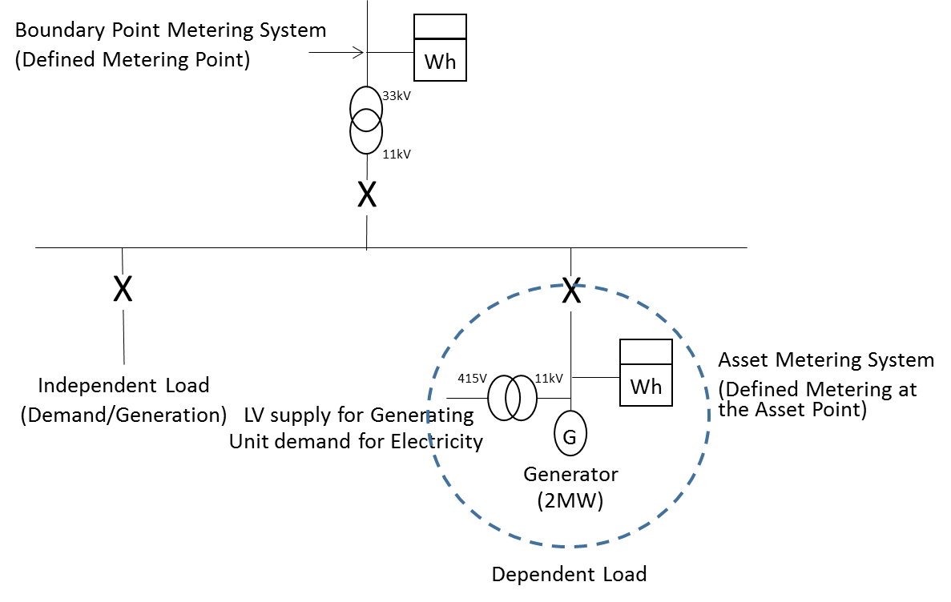
Figure 1: Asset Metering System physical location (Generating Asset)

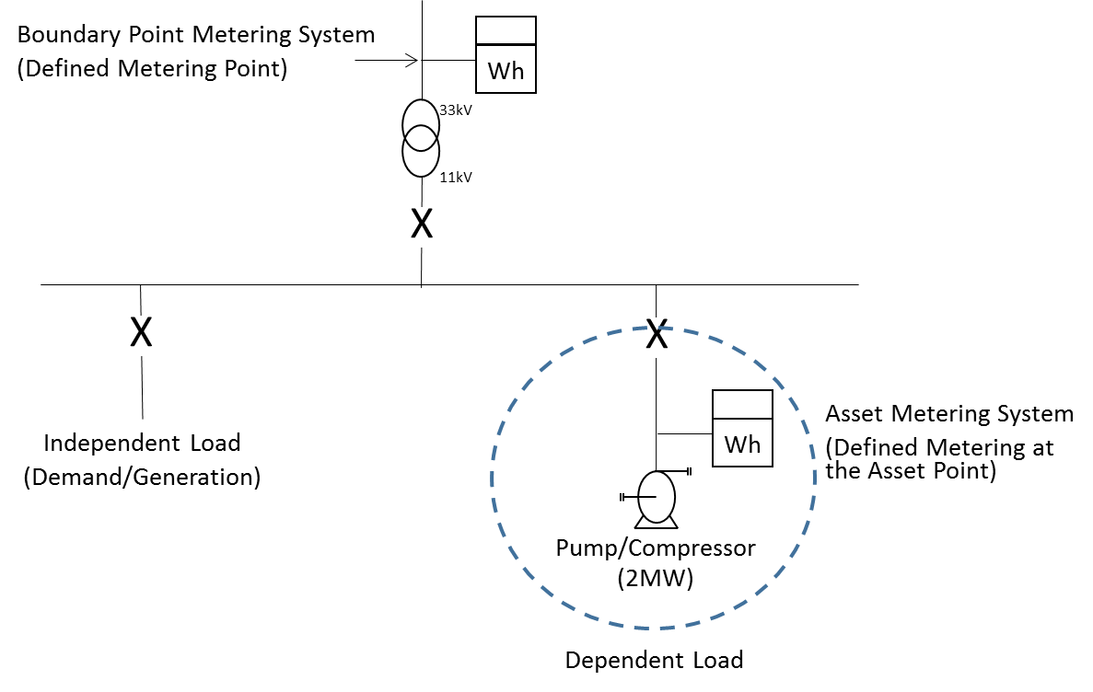
Figure 2: Asset Metering System physical location (Demand Asset)

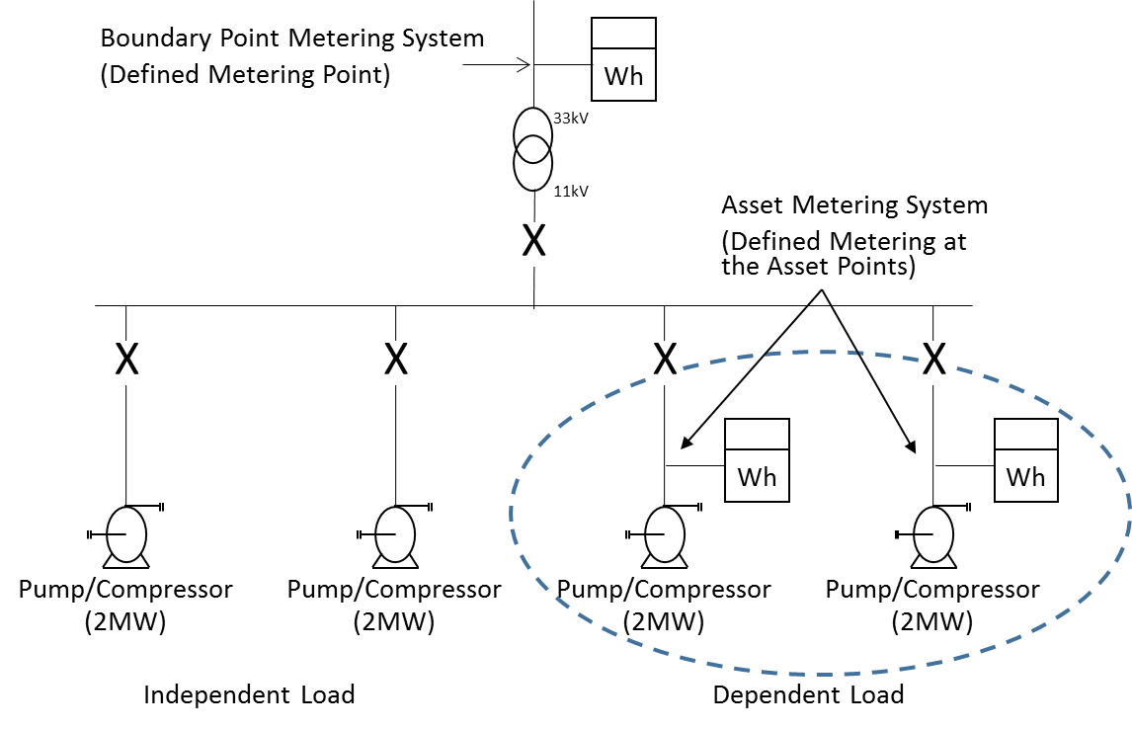
Figure 3: Multiple Asset Metering Systems physical location (Demand Asset)

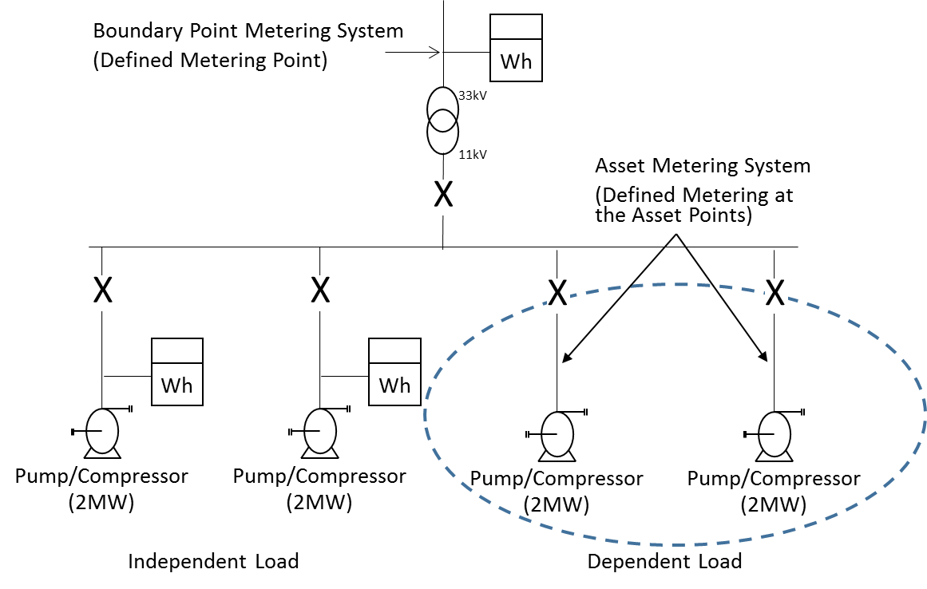
Figure 4: Difference Metering physical location of Asset Metering (Demand Asset)

In the case of Difference Metering the Metered Volumes from the Boundary Point Metering System must be available and that Metering System must be registered in the Supplier Meter Registration Service. The Metered Volumes for the Asset Dependent Load is determined by differencing the Boundary point Metering System Metered Volumes from the Asset Metering Systems measuring the Metered Volumes of the Independent Load for the site.
The formula to derive the Asset Dependent Load Metered Volumes would be:
Asset Dependent Load Metered Volumes = [Boundary Point Metering System (Active Export – Active Import)] - [Aggregated Independent Load Metering System (Active Export – Active Import)]

APPENDIX B – IMPORT/EXPORT CONVENTION
The convention for import and export Active Energy flows for the Asset is defined as:
Asset Export: Any flow of Active Energy that is coming from the Asset towards the Boundary Point Metering System
Asset Import: Any flow of Active Energy that is coming from the Boundary Point Metering System towards the Asset.
This is illustrated in Figure 5.

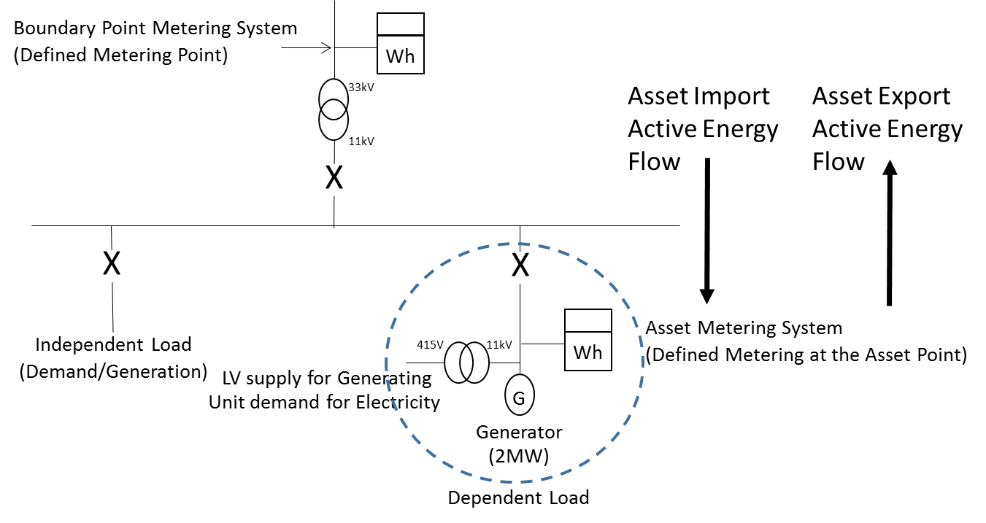
Figure 5: Asset Import and Export energy flow example

APPENDIX C – HALF HOURLY INTEGRAL OUTSTATION / SEPARATE OUTSTATION REQUIREMENTS

This appendix is only applicable to Asset Meters that are Half Hourly Integral Outstation Meters or separate Outstations approved by the Panel in accordance with BSCP601. This approval will be for Code of Practices 1, 2, 3, 5 and 10 as applicable.

The following requirements for BSCP601 approval are taken from Codes of Practice 1, 2, 3, 5 and 10. In the event of an inconsistency between the provisions of this Code of Practice and the Code of Practice 1, 2, 3, 5 and 10 (as applicable), the provisions of Code of Practice 1, 2, 3, 5 and 10 (as applicable) shall prevail.

Outstation
Where separate Outstations are provided these shall each store main and check Asset Meter data for one or more circuits and where practicable shall be configured identically.
Separate Outstations storing data from different circuits may be cascaded on to one communication line.
Asset Metering Systems comprising Meters with integral Outstations need not store data from the associated main or check Asset Meter.
The Outstation data shall be to a format and protocol approved by the Panel in accordance with BSCP601.
The Outstation shall have the ability to allow the metering data to be read by instations other than the Settlement Instation provided the requirements of access to data of this Code of Practice are satisfied.
Access to metering data shall be in accordance with the provisions of the Code and the BSC Procedures referred to therein. Such access must not interfere with or endanger the security of the data or the collection process for Settlement purposes.
Access to stored metering data in Outstations shall also be the right of the Registrant and any party who has the permission of the Registrant.
Facilities shall be provided to select a relevant Demand Period from one of the following values:-
- 30, 20, 15, 10 and 5 minutes with one demand period ending on the hour.
Normally metering data will be collected by the Settlement Instations by a daily interrogation, but repeat collections of metering data shall be possible throughout the Outstation data storage period.
Where the circuit the Asset Meter is connected to is not normally energised the Outstations shall be fitted with an auxiliary terminal that provides for the Outstation’s energisation for remote interrogation purposes.
Where a separate modem associated with the Outstation System is used, then it shall be provided with a secure supply separately fused. Alternatively, line or battery powered modem types may be used.
The Outstations shall provide an alarm output signal at a manned point in the event of a supply failure.

Displays
The Metering Equipment shall display the following primary information (not necessarily simultaneously):
- Mandatory Displays:

- Measured quantities as per clause 4;
- Current time (“UTC”) and date;
- Measurement Transformer ratios (see clause 6.1); and
- Any compensation factor which has been applied for Measurement Transformer errors and/or system losses, where this is a constant factor applied at security level 3 (i.e. where the Asset Meter is combined with the display and/or Outstation).
Asset Metering Equipment shall be capable of enabling the display of the following, as specified by the Registrant:
- Display capabilities:
- Maximum Demand (MD) for kW or MW as appropriate per programmable charging period i.e. monthly or statistical review period;
- Maximum Demand (MD) for kVA or MVA as appropriate per programmable charging period i.e. monthly or statistical review period;
- Twice the kWh advance or MWh advance as appropriate since the commencement of a current Demand Period (i.e. kW or MW rising demand);
- Cumulative MD;
- Number of MD resets; and
- Multi-rate display sequence as specified by the Registrant with a minimum of 8 rates selectable over the calendar year. MD shall be resettable at midnight of the last day of the charging period and for part chargeable period demands. If a manual reset button is provided then this shall be sealable;
- indication of reverse running for Active Energy, where appropriate for Asset Metering Types 3 and 4.

Data storage
Data storage facilities for metering data shall be provided as follows:-
    - A storage capacity of 48 periods (assuming 30 minute Demand Period) per day for a minimum of 10 days for Asset Metering Types 1 and 2 and 20 days for Asset Metering Types 3 and 4 for all Demand Values;
    - The stored Demand Values shall be integer values of kW/MW or kvar/Mvar as appropriate, or pulse counts, and have a resolution of better than +0.1% (at full load);
    - The accuracy of the energy values derived from Demand Values shall be within +0.1% (at full load) of the amount of energy measured by the associated Asset Meter;
    - The value of any energy measured in a Demand Period but not stored in that Demand Period shall be carried forward to the next Demand Period;
    - Where a separate Outstation is used, cumulative register values shall be provided in the Outstation which can be set to match and increment with the Meter Registers;
    - In the event of an Outstation supply failure, the Outstation shall protect all data stored up to the time of the failure, and maintain the time accuracy in accordance with Appendix C clause 4 (Time Keeping);
    - Partial Demand Values, those in which an Outstation supply failure and/or restoration occurs, and zero Demand Values associated with an Outstation supply failure, shall be marked so that the Settlement Instation can identify them;
    - To cater for continuous supply failures, the clock, calendar and all data shall be supported for a period of 10 days for Asset Metering Types 1 and 2 and 20 days for Asset Metering Types 3 and 4 without an external supply connected;
    - Any “read” operation shall not delete or alter any stored metered data; and
    - An Outstation shall provide any portion of the data stored upon request by an instation.

Time Keeping
    - The Outstation time shall be set to the Universal Time Clock (UTC) also known as Greenwich Mean Time (GMT). No switching between UTC and British Summer Time (BST) shall occur
    - Time synchronisation of the Outstation shall only be performed by communication with the Settlement Instation.
    - The overall limits of error for the time keeping allowing for a failure to communicate with the Outstation for an extended period of 10 days for Asset Metering Types 1 and 2 and 20 days for Asset Metering Types 3 and 4 shall be:-
- the completion of each Demand Period shall be at a time which is within ± 10 seconds of UTC for Asset Metering Types 1 and 2 or ± 20 seconds of UTC for Asset Metering Types 3 and 4; and
- the duration of each Demand period shall be within ± 0.1%, except where time synchronisation has occurred in a Demand Period.

Monitoring Facilities
Monitoring facilities shall be provided for each of the following conditions and shall be reported, tagged wherever possible to the relevant Demand Period(s), via the local interrogation facility:-
    - Error in Outstation functionality;
    - Battery monitoring (where battery fitted); and
    - Interrogation port access which changes data.
In addition all of the above conditions shall be reported as, at minimum, a common alarm indication via the remote interrogation facility.

Communications
For integral Outstations: Outstation(s) shall accommodate both local and remote interrogation facilities, from separate ports.
To prevent unauthorised access to the data in the Metering Equipment a security scheme, as defined below, shall be incorporated for both local and remote access. Separate security levels shall be provided for the following activities:
    - Level 1 Password for:
Read-only access to the following metering data, which shall be transferrable on request during the interrogation process:
- Outstation ID;
- Demand Values as defined in clause 4;
- Cumulative measured quantities as defined in clause 4;
- Maximum Demand (MD) for kW/MW or kVA/MVA as appropriate per programmable charging period i.e. monthly or statistical review period;
- Multi-rate cumulative Active Energy as specified by the Registrant;
- Measurement Transformer ratios, where appropriate (see clause 6.1);
- Measurement Transformer error correction factor and/or system loss factor where this is a constant factor applied to the entire dynamic range of the Asset Meter and the Asset Meter is combined with the display and/or Outstation;
- Alarm indications; and
- Outstation time and date.

- Level 2 Password for:

- Corrections to the time and/or date; and
- Resetting of the MD.

- Level 3 Password for:
Programming of:
- Displays and facilities as defined in Appendix C clause 2;
- Measurement Transformer ratios, as appropriate (see clause 6.1);
- Measurement Transformer error correction and/or system loss factor where this is a constant factor applied to the entire dynamic range of the Asset Meter and the Asset Meter is combined with the display and/or Outstation; and
- Passwords for levels 1, 2 and 3.

In addition it shall be possible to read additional information within the Metering Equipment to enable the programmed information to be confirmed.

- Level 4 Password for

- Calibration of the Metering Equipment;
- Setting the Measurement Transformer ratios, where appropriate (see clause 6.1);
- Setting the transformer error correction and/or system loss factors where this is other than a single factor; and
- Programming the level 3 Password and the level 4 Password if appropriate.
In addition to the functions specified for each level it shall be feasible to undertake the functions at the preceding level(s); e.g. at level 3 it shall also be possible to carry out the functions specified at levels 1 and 2. This need not apply at level 4 when access is obtained via removing the cover. Different Passwords shall be utilised for each level, which shall only be circulated in accordance with the relevant BSC Procedure.
For separate Outstations: A Password shall be required to read or change any data.
The Passwords specified in Appendix C clause 6 shall be subject to the following additional requirements:
- The communications protocol employed shall ensure that the Password offered determines the level of access to the data within the Metering Equipment.
- A counter to log the number of illegal attempts (i.e. Password comparison failures) to access Metering Equipment via the local and remote ports shall be incorporated into the log-on process. This counter shall reset to zero at every hour change (i.e. 0100, 0200 etc).
- If the counter reaches 7, then access is prohibited at all levels until the counter resets at the next hour change.

Local Interrogation
An interrogation port shall be provided for each Outstation which preferably shall be an optical port to BS EN/IEC 62056-21, and with a serial protocol such as BS EN/IEC 62056-21, for the following purposes:-
    - Commissioning, maintenance and fault finding;
    - Transfer of metering data and alarms; and
    - Time setting.

Remote Interrogation
Remote interrogation shall be provided with error checking of the communications between the Outstation System and the Settlement Instation.
Interrogation of an Outstation shall be possible using one of the following media (future proofing and the end of life timeline for a communications method should be considered when choosing a communications option):-
- Switched telephone networks e.g. PSTN or CTN;
- Public data networks e.g. PSN;
- Internet Protocol;
- Global System for Mobile communications (GSM);
- Radio data networks e.g. Paknet or any equivalent;
- Customer's own network;
- Mains signalling / power line carrier;
- Low power radio;
- Satellite; or
- Cable TV.
In addition any further media may be used as approved by the Panel.
The data shall be to a format and protocol approved by the Panel in accordance with BSCP601.

APPENDIX D – COMMISSIONING REQUIREMENTS
Commissioning shall be performed on all new Metering Equipment which is to provide metering data for Settlement.
The commissioning requirements are split between Asset Meters that are Whole Current (Direct Connected) and that are Measurement Transformers (current and voltage transformers) connected.
It is the responsibility of the Registrant to ensure that the installer is suitably trained and qualified to install and commission Asset Metering equipment behind the Boundary Point Metering System; this shall include working in a domestic location where applicable.

- Whole Current (Direct Connected) Metering:
- The installer will confirm that the direction of power flow is the same as is registered against the Metering System for Settlement (Import or Export);
- The installer will confirm phase rotation is standard at the Asset Meter terminals, or the incoming terminals to the device that the metering device is embedded within;
- The installer will confirm that the polarity is standard at the Asset Meter terminals, or the incoming terminals to the device that the metering device is embedded within; and
- The installer will confirm that the Metering Equipment detects and operates any alarms required by this Code of Practice.
- Measurement Transformers (current and voltage transformers) Metering:
The equipment owner shall be responsible for ensuring the requirements of this Appendix D, are performed on its Metering Equipment up to and including the Testing Facilities, if fitted; where not fitted this will be to the Asset Meter or a point where the Asset Meter can be isolated from the Measurement Transformers. In addition that Party shall prepare, and make available upon request, complete and accurate commissioning records in relation to these obligations. Where Measurement Transformers are owned by the Registrant or Asset Meter installer it shall be responsible for the Commissioning of all Metering Equipment.
This section assumes that the Measurement Transformers may not be owned by the installer of the Asset Meter or the Registrant. The equipment owner is the responsible Party for equipment housing Measurement Transformers associated with the Asset Metering System. Where this is not another Party, the following requirements will be the responsibility of the Registrant via its appointed Asset Meter installer.
- The equipment owner will confirm that the current transformers match the ratio and polarity declared to the installer of the Asset Meter on all relevant documentation;
- The equipment owner will confirm that the voltage transformers match the ratio and polarity declared to the installer of the Asset Meter on all relevant documentation;
- The equipment owner will confirm that the relationships between voltages and currents are correct and that phase rotation is standard at the Testing Facilities, if fitted; or at the Asset Meter or a point where the Asset Meter can be isolated from the Measurement Transformers;
- The equipment owner will measure and record the burdens on the Measurement Transformers up to the Testing Facilities, if fitted; or at the Asset Meter or a point where the Asset Meter can be isolated from the Measurement Transformers;
- The installer of the Asset Metering will confirm that the relationships between voltages and currents are correct and that phase rotation is standard at the Asset Meter terminals;
- The installer of the Asset Metering will measure and record the burdens on the Measurement Transformers from the Testing Facilities, if fitted or a point where the Asset Meter can be isolated from the Measurement Transformers, to the Asset Meter and ensure that the overall burden on the Measurement Transformers does not exceed the rated burden. Where the equipment owner has measured and recorded the burden up to the Asset Meter the installer does not have to repeat this test.;
- The installer of the Asset Meter will confirm that the Asset Meters are set to the same current transformer and voltage transformer ratios as declared by the equipment owner on all relevant documentation;
- The installer of the Asset Meter will confirm that the Asset Meters have the correct compensation for errors in the Measurement Transformers/connections and losses in power transformers where appropriate;
- The output of the Asset Metering System correctly records the energy in the primary system at the Defined Metering at the Asset Point; and
- The installer of the Asset Meter will confirm that the Metering Equipment detects and operates the alarms required by this Code of Practice if applicable.
Where individual items of Metering Equipment are to be replaced then only those items are required to be Commissioned. For clarification, Asset Metering Systems in their entirety need not be re-Commissioned when items are replaced within that system.
Current transformers⁸ integrated in low voltage cut outs or switchgear may be partially Commissioned off site, provided there is no further alteration to the Metering Equipment following Commissioning and provided that this is done in accordance with Appendix D of this Code of Practice (other than the requirement that the Commissioning be performed on site). On site Commissioning tests will still be required on site by the equipment owner/Asset Meter installer to ensure all of the obligations under Appendix D of this Code of Practice are met⁹. Tamper evident seals shall be used following off site Commissioning and these shall be replaced on site by seals as specified in Section 8 once Commissioning is complete.

- Commissioning by Comparison to the Boundary Point
Where the Boundary Point Metering System can show the impact of the Dispatchable Asset a comparison between the Asset Meter, with the Asset despatched, and the Boundary Point Metering System can be used in lieu of Measurement Transformer commissioning tests. For the avoidance of doubt commissioning of the Asset Meter is still required to be completed.
The criteria that must be met to use this technique are as detailed below:
- Half Hourly Metered Volumes from the Boundary Point Metering System for the Demand Period the Asset was despatched in and all relevant Baseline Periods must be available;
- Any Baseline Period where the Asset has been despatched must be provided and these discounted from the determination of the Baseline Period value;
- Any Independent Load behind the Boundary Point Metering System must be not change its mode of operation during the period the Asset is despatched for a commissioning test; and
- The electrical losses between the Defined Metering at the Asset point and the Defined Metering Point of the Boundary Point Metering System shall be calculated to demonstrate the losses will have no significant impact on the comparison of Metered Volumes.
The Baseline Periods required are:

Where the Asset is dispatched on a working day the same Demand Period for the previous seven working days, and in addition the three previous and three subsequent Demand Periods for each day; OR

Where the Asset is dispatched on a non-working day that is a Saturday the same Demand Period for the previous seven Saturdays, and in addition the three previous and three subsequent Demand Periods for each day; OR

Where the Asset is dispatched on a non-working day that is a Sunday the same Demand Period for the previous seven Sundays, and in addition the three previous and three subsequent Demand Periods for each day;

If the Asset is dispatched on a Bank Holiday this will be treated as a Sunday.

The Baseline Periods for the Boundary Point Metering System will be averaged and the difference between the average and the Demand Period the Asset was dispatched will be used as a comparison with the Asset Metering System Metered Volumes from the period the Asset was dispatched.

Any Baseline Periods where the Asset has been dispatched shall be accounted for.

The comparison between the half hourly Metered Volumes in the period the Asset is dispatched and the Boundary Point Metering System deviation in the same period from the Boundary Point Metering System Baseline Period average must be within ±5%.

If a commissioning test was carried out on the 18th July 2019 and the Asset was dispatched in Settlement Period (SP in table below) 28 the Baseline Periods required would be as illustrated in Table 14 below:

Table 14: Commissioning by Comparison to the Boundary Point Example
 | BASELINE PERIODS  (Boundary Point Metering System kWh) |  |  |  |  |  |  | COMMISSIONING PERIODS
Date/  SP | 09/07/19 | 10/07/19 | 11/07/19 | 12/07/19 | 15/07/19 | 16/07/19 | 17/07/19 | 18/07/19
SP25 | 466 | 486 | 466 | 462 | 441 | 453 | 450 | 466
SP26 | 465 | 476 | 480 | 476 | 449 | 460 | 463 | 470
SP27 | 456 | 483 | 477 | 480 | 453 | 459 | 466 | 468
SP28 | 457 | 494 | 487 | 475 | 440 | 465 | 472 | 250
SP29 | 453 | 501 | 481 | 480 | 450 | 466 | 468 | 480
SP30 | 480 | 491 | 469 | 469 | 445 | 470 | 472 | 472
SP31 | 471 | 480 | 472 | 474 | 452 | 458 | 458 | 469

Taking the average of SP28 during the Baseline Period in this example we would get a figure of 470kWh ((ƩSP28)/7). The difference between the Baseline Period average and the Demand Period the Asset was dispatched is 220kWh (i.e. 470kWh – 250kWh).

So long as the Asset Meter has recorded 220kWh ±11kWh (i.e. ±5% tolerance limit allowed) the commissioning test will have been passed.

In this example the Asset was not dispatched during any of the Baseline Periods; should it have been this will have to be accounted for in the Baseline Period averaging calculation.

All Demand Periods used for this commissioning technique and the calculations carried out to prove compliance shall be available for inspection by the Panel or Technical Assurance Agent.

APPENDIX E – SINGLE LINE DIAGRAM REQUIREMENTS

The Single Line Diagram must include the location of the Boundary Point Metering System and the associated identifiers. For the Import ID this will be the Import MPAN for a Metering System registered in the Supplier Meter Registration Service; should the site be registered for export for the Export ID this will be the Export MPAN for a Metering System registered in the Supplier Meter Registration Service.
It should also show the location of all Asset Metering Systems and what is Dependent Load and Independent Load.
The Single Line Diagram shall be available for inspection by the Panel or Technical Assurance Agent.
Figure 6 shows an example of what is required.

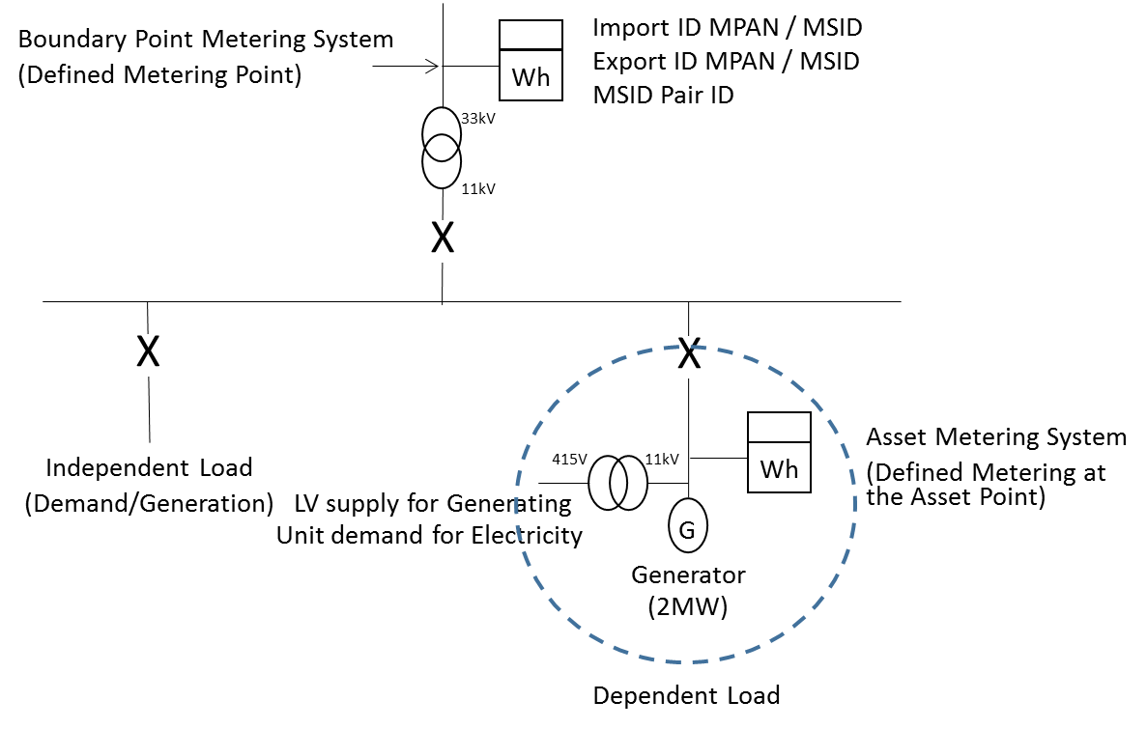
Figure 6: Single Line Diagram example

APPENDIX F – ASSET METERING COMPLEX SITE SUPPLEMENTARY INFORMATION FORM (COP11/FA)
There are three scenarios where an Asset Metering Complex Site Supplementary Form should be used:
- Difference Metering – Where the Metered Volumes are derived from a combination of the Boundary point Metering System Metered Volumes and one or more Asset Metering Systems;
- System Losses – Where the Asset Meter is not located at the Defined Metering at the Asset Point and a loss factor has been applied to account for equipment and cabling between the Actual Metering Point and the Defined Metering at the Asset Point; and
- Inverter Losses – Where the location of the Asset Meter where it is Asset Metering Type 5 is in such a place that it does not account for the losses of the inverter.

- Difference Metering
Where a Difference Metering method is being used all Boundary Point Metering System and Asset Metering System Ids must be included in the Asset Metering Complex Site Supplementary Form (CoP11/Fa). There can be a number of options to consider (for the avoidance of doubt other combinations of options are possible and the following examples are only to illustrate the high level principles):

Option 1: Single Boundary Point - Import MPAN only / Single Asset Metering System ID - Import
Where the Virtual Lead Party (VLP) Asset has an Import identifier of 1256347890321.
Where the Boundary Point MPAN is 1200012345678 and the Asset Metering System ID is 1234567890123 the aggregation rule would be:
Asset 1256347890321 = 1200012345678 - 1234567890123
The VLP Asset ID (Import), even though derived from other Metering Systems, should be listed in the Asset Metering Complex Site Supplementary Form.
One Boundary Point Metering System ID (Import) and one Asset Metering System ID (Import) should be listed in the Asset Metering Complex Site Supplementary Form.

Option 2: Single Boundary Point - Import MPAN only / Single Asset Metering System ID – Export
Where the Virtual Lead Party (VLP) Asset has an Import identifier of 1256347890321.
Where the Boundary Point MPAN is 1200012345678 and the Asset Metering System ID is 1234567890987 the aggregation rule would be:
Asset 1256347890321 = 1200012345678 + 1234567890987
The VLP Asset ID (Import), even though derived from other Metering Systems, should be listed in the Asset Metering Complex Site Supplementary Form.
One Boundary Point Metering System ID (Import) and one Asset Metering System ID (Export) should be listed in the Asset Metering Complex Site Supplementary Form.

Option 3: Single Boundary Point - Import MPAN only / Single Asset Metering System ID – Import and Export
Where the Virtual Lead Party (VLP) Asset has an Import identifier of 1256347890321.
Where the Boundary Point MPAN is 1200012345678 and the Asset Metering System IDs are 1234567890123 (Import) 1234567890987 (Export) the aggregation rule would be:
Asset 1256347890321 = 1200012345678 + (1234567890987 – 1234567890123)
The VLP Asset ID (Import), even though derived from other Metering Systems, should be listed in the Asset Metering Complex Site Supplementary Form.
One Boundary Point Metering System ID (Import) and two Asset Metering System IDs (Import and Export) should be listed in the Asset Metering Complex Site Supplementary Form.

Option 4: Single Boundary Point - Import and Export MPAN / Single Asset Metering System ID - Import
Where the Virtual Lead Party (VLP) Asset has an Import identifier of 1256347890321.
Where the Boundary Point MPANs are 1200012345678 (Import) and 1200087654321 (Export) and the Asset Metering System ID is 1234567890123 the aggregation rule would be:
Asset 1256347890321 = (1200087654321 – 1200012345678) - 1234567890123
The VLP Asset ID (Import), even though derived from other Metering Systems, should be listed in the Asset Metering Complex Site Supplementary Form.
Two Boundary Point Metering System IDs (Import and Export) and one Asset Metering System ID (Import) should be listed in the Asset Metering Complex Site Supplementary Form.

Option 5: Multiple Boundary Points – Import MPANs only / Single Asset Metering System ID - Import
Where the Virtual Lead Party (VLP) Asset has an Import identifier of 1256347890321.
Where there are two Boundary Point connections with MPANs 1200012345678 (Import) and 1200043218765 (Import) and the Asset Metering System ID is 1234567890123 the aggregation rule would be:
Asset 1256347890321 = (1200043218765 + 1200012345678) - 1234567890123
The VLP Asset ID (Import), even though derived from other Metering Systems, should be listed in the Asset Metering Complex Site Supplementary Form.
Two Boundary Point Metering System IDs (both Import) and one Asset Metering System ID (Import) should be listed in the Asset Metering Complex Site Supplementary Form.

Option 6: Multiple Boundary Points – Import MPANs and Export MPANs / Single Asset Metering System ID - Import
Where the Virtual Lead Party (VLP) Asset has an Import identifier of 1256347890321.
Where there are two Boundary Point connections with MPANs 1200012345678 (Import) / 1200022222222 (Export) and 1200043218765 (Import) / 1200077777777 (Export) and the Asset Metering System ID is 1234567890123 the aggregation rule would be:
Asset 1256347890321 = [(1200022222222 - 1200012345678) + (1200077777777 - 1200043218765)] - 1234567890123
The VLP Asset ID (Import), even though derived from other Metering Systems, should be listed in the Asset Metering Complex Site Supplementary Form.
Two Boundary Point Metering System IDs (both with Import and Export) and one Asset Metering System ID (Import) should be listed in the Asset Metering Complex Site Supplementary Form.

Option 7: Single Boundary Point - Import MPAN only / Multiple Asset Metering System IDs - Import
Where the Virtual Lead Party (VLP) Asset has an Import identifier of 1256347890321.
Where the Boundary Point MPAN is 1200012345678 and the Asset Metering System IDs are 1234567890123 and 1234567890888 the aggregation rule would be:
Asset 1256347890321 = 1200012345678 – (1234567890123 + 1234567890888)
The VLP Asset ID (Import), even though derived from other Metering Systems, should be listed in the Asset Metering Complex Site Supplementary Form.
One Boundary Point Metering System ID (Import) and two Asset Metering System IDs (both Import) should be listed in the Asset Metering Complex Site Supplementary Form.

Option 8: Single Boundary Point - Import and Export MPAN / Single Asset Metering System ID - Import
Where the Virtual Lead Party (VLP) Asset has an Import identifier of 1256347890321 and an Export identifier of 1256347890654. In this scenario the Asset is capable of importing and exporting and the convention for the aggregation rule is that where the result of the rule is negative it is a net Import position for the Asset the metered volumes are allocated to the Asset Import Identifier (i.e. 1256347890321 in this example); and where the result is positive it is a net export position for the Asset the metered volumes are allocated to the Asset Export Identifier (i.e. 1256347890654 in this example).
Where the Boundary Point MPANs are 1200012345678 (Import) and 1200087654321 (Export) and the Asset Metering System ID is 1234567890123 the aggregation rule would be:
If ((1200087654321 – 1200012345678) - 1234567890123) > 0 then
Asset 1256347890654 = ((1200087654321 – 1200012345678) - 1234567890123); OR
Asset 1256347890321 = ((1200087654321 – 1200012345678) - 1234567890123)
Endif
It should be noted that the convention for BM Units is that a Net Export position is a positive value and Net Import position is a negative value, this process mimics that convention.
Both the VLP Asset IDs (Import and Export), even though derived from other Metering Systems, should be listed in the Asset Metering Complex Site Supplementary Form.
Two Boundary Point Metering System IDs (both with Import and Export) and one Asset Metering System ID (Import) should be listed in the Asset Metering Complex Site Supplementary Form.

- System Losses

Where the Asset Meter is not located at the Defined Metering at the Asset Point and a loss factor needs to be applied to account for equipment and cabling between the Actual Metering Point and the Defined Metering at the Asset Point these losses must be accounted for in the aggregation rule using the Asset Metering Complex Site Supplementary Information Form (CoP11/Fa). The losses in the inverter must be independently verified and results made available for inspection by the Panel or Technical Assurance Agent.
Where the Asset Metering System ID is 1234567890111 and the losses between the Actual Metering Point and the Defined Metering at the Asset Point have been calculated as 2% the aggregation rule would be:
Asset 1234567890111 = 1234567890111 x 1.02
One Asset Metering System ID (Import) should be listed in the Asset Metering Complex Site Supplementary Form.

- Inverter Losses

Where the device is converting a.c. electrical quantities to d.c. electrical quantities and the metering device is not in such a place within the product to account for any losses associated with the inverter these losses must be accounted for in the aggregation rule using the Asset Metering Complex Site Supplementary Information Form (CoP11/Fa). The losses in the inverter must be independently verified and results made available for inspection by the Panel or Technical Assurance Agent.

Where the Asset Metering System ID is 1234567890333 and the losses associated with the inverter have been independently verified as 5% the aggregation rule would be:
Asset 1234567890333 = 1234567890333 x 0.95
One Asset Metering System ID (Import) should be listed in the Asset Metering Complex Site Supplementary Form.
CoP11/Fa Asset Metering Complex Site Supplementary Information Form (CoP11/Fa)
From VLP |  |  |  | Metering System Arrangement Description
To SVAA
Boundary Point Metering System ID (1) |  |  | IMPORT/EXPORT*
Boundary Point Metering System ID (2) |  |  | IMPORT/EXPORT*
Boundary Point Metering System ID (3) |  |  | IMPORT/EXPORT*
Asset Metering System ID (1) | IMPORT/EXPORT*
Asset Metering System ID (2) | IMPORT/EXPORT*
Asset Metering System ID (3) | IMPORT/EXPORT*
Address of site
Aggregation Rule
Notes:
* Delete as appropriate
Add Boundary Point Metering System IDs and Asset Metering System IDs as required. Import and Export MSIDs shall be listed on separate rows.
Signature: ……………………………………………………………………………… Date: …………………………………………….
Name: ………………………………………………………………………………

This excludes cases where a dynamic range of compensation factors have been applied
8 Where current transformers are of a multi-ratio design, then the responsible Commissioning party will be required to complete elements of Commissioning on-site (and post installation) to ensure the correct ratio has been selected.
9 For the avoidance of doubt, where current transformers are Commissioned off site then the equipment owner will not be required to complete additional tests outside of the scope of Appendix D of this CoP. The Asset Meter installer testing should not be altered by off site Commissioning of current transformers integrated in low voltage cut-outs or switchgear.

